Name _____________________________________________ Date _________________ Period _____
Review: Characteristics of Life AND Climates and biomes

Answer all the questions below and include details when possible.

1. Describe the climate, geography, and organisms of a taiga biome. Include at least 3 abiotic factors and 3 biotic factors. Circle the biotic factors in your description and underline the abiotic factors.

2. Consider the 6 kingdoms: Animals, Plants, Protists, Fungi, Eubacteria, Archaebacteria
Write the name of each kingdom that has or can have the characteristic listed. The first one is done for you.

a. is multicellular ____animals plants protists fungi________________________

b. is unicellular ______________________________________________________________

c. makes its own food (through photosynthesis) ____________________________________

d. decomposes dead organisms _________________________________________________

e. can move on its own _______________________________________________________

f. has a cell wall ____________________________________________________________

g. has a nucleus _____________________________________________________________

3. The organisms below were observed in the lab. For each organism, identify the kingdom and explain your identification based on characteristics of the organism.

a. volvox:

b. hydra:

c. paramecium:

d. planaria:

e. elodea:

4. Describe each of the following, by listing one or more components, for a tundra biome.

a. organism b. population

c. community d. ecosystem

5. Match the parts of the microscope with their function.

a. diaphragm * magnifies the object

b. stage *controls the amount of light on the object

c. objective * holds the slide

5. What is the magnification for each objective below? Assume the eyepiece has a magnification of 10X.

4X objective _____________ 10X objective ______________ 40X objective _____________

- Show the location of the biomes listed using labels or arrows on the world map.
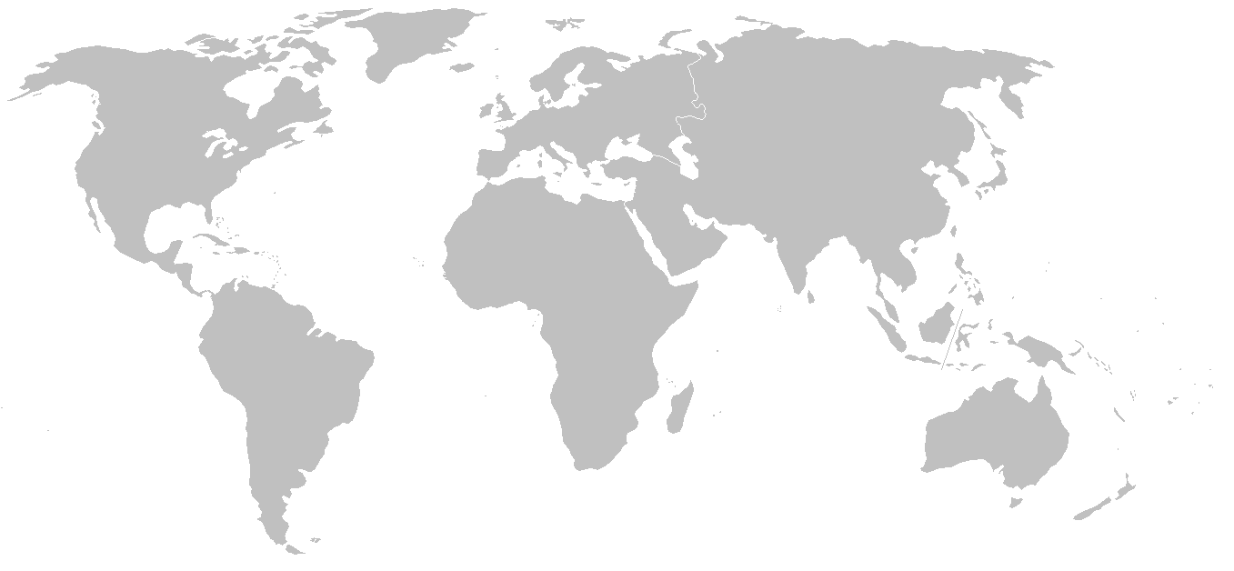
Grassland
Taiga
Desert
Tropical rainforest
Tundra
Temperate rainforest
Chaparral
Savanna

- Name the biome shown and identify 3 biotic factors and 3 abiotic factors that would be present.
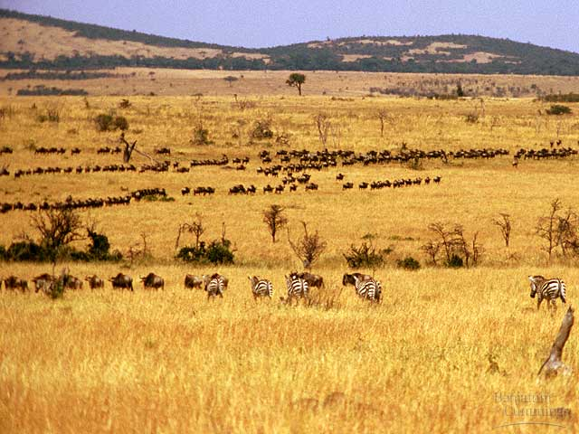
- Describe the properties of one plant and one animal that are typically found in the biome you researched.
Explain how the climate is responsible for these properties.

- Look at the graphs of temperature and precipitation below and
- Identify the most likely biome
- Explain your identification based on temp and precipitation. Include numbers
- Name 2 plants and 2 animals that are likely to be found in this biome.

- 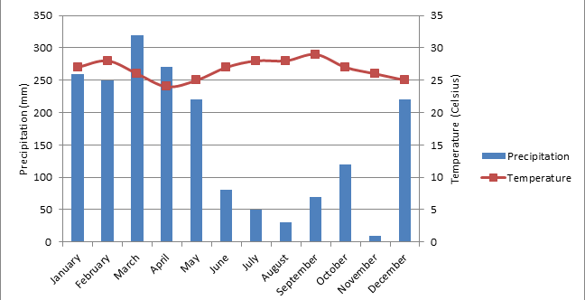
Average temperature (C)
Precipitation (cm)
temp
precip

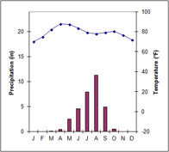
d.
- Label the diagram below. Include the following on each “Earth”:
- Northern Hemisphere
- Southern Hemisphere
- Winter, summer, spring, autumn for N. Hemisphere AND S. Hemisphere. (2 of these on each Earth)

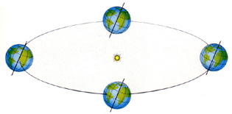
11. Explain how the tilt of the axis affects the intensity of the energy from the sun.

12. Explain why the average temperatures are higher near the equator and lower near the North and South Poles.

13. Use the below to describe how the hours of daylight vary for the Arctic Circle, Anchorage, Alaska, Jacksonville, Florida, and the Quito, Equador.

Hours of Daylight over 12 Months
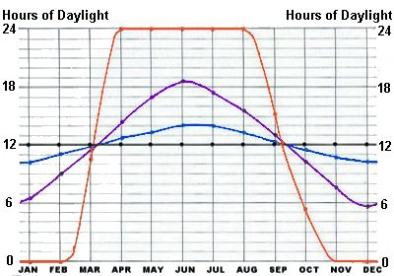
Arctic Circle

Anchorage

Quito

Jacksonville
Time (months)

Explain why daylight hours vary this way

