Name _____________________________________________ Date ___________ Period ________

Acid-Base Neutralization Reactions
Information:
Acid – a compound that produces H⁺ (aq), hydrogen ions (or hydronium ions, H₃O⁺ (aq)) as positive ions in aqueous solution, a solution with H⁺ > OH⁻
Base – a compound that produces OH⁻ (aq), hydroxide ions as negative ions in aqueous solution,
a solution with OH⁻ > H⁺
Neutral solution – contains hydrogen (or hydronium) ions and hydroxide ions in equal concentrations.
Spectator ions – ions present in acidic and basic solutions that do not participate in the neutralization reaction between the H⁺(aq) (hydrogen ions) and OH⁻(aq) (hydroxide ions). Spectator ions can be positive or negative, and they are present in quantities needed to produce electrically neutral solutions.

A/B Model:
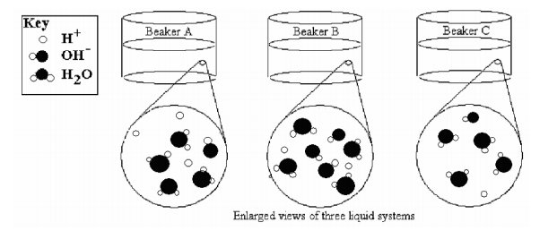
Note: spectator ions are not shown in this model, but they are present in each solution.

Key Questions
- Compare the amount (concentration) of H⁺ and OH⁻ in the each solution above.
Solution A | Solution B | Solution C

- Identify the acidic solution in the model. ___________________________

- Identify the basic solution in the model. ____________________________

- Identify the neutral solution in the model. __________________________
Exercises
- Based upon the information presented in the key of the Model, draw reactants and products when an H⁺ ion is combined with an OH⁻ ion to form a compound.

Write a balanced equation for the reaction above.

- Would the final solution be acidic or basic if solution A and solution B were mixed? Explain your answer.

Neutralization (titration) Calculations
In a neutral solution the moles of H⁺ = moles of OH⁻

Molarity (M) = moles solute
1 liter solution

Problems
- How many moles of H⁺ ions are present in 1 liter of 2.0 M HCl? Explain your reasoning.

- How many moles of OH⁻ ions are needed to completely neutralize 1 liter of 2.0 M HCl?

- How many moles of OH⁻ ions are present in one liter of 0.50 M NaOH? Explain your reasoning.

- How many moles of H⁺ ions are needed to completely neutralize one liter of 0.50 M NaOH?

- How many moles of OH⁻ are needed to completely neutralize 0.50 liter of 2.0 M HCl?

Using Stoichiometry in Neutralization (titrations)
Refer to the following example to solve the following problems.

How many mL of 2.0 M NaOH are required to exactly neutralize 100.0 mL of a 3.0 M solution of HBr?
- Write a balanced equation: NaOH + HBr NaBr + H2O
Notice: for every mole of HBr, there is 1 mole of H⁺ and for every mole of NaOH, there is 1 mole of OH⁻

- Determine the moles of H⁺: 3.0M = x mol x = 0.30 molH⁺ , therefore 0.300 mol of OH⁻ is needed
0.100L
c. Determine the mL of NaOH: 2.0M = 0.30 mol x = 0.15 L, 0.15 L of NaOH is required to neutralize the HBr
x L

Refer to the example above to solve #12-13.
- How many mL of 2.0 M HBr are needed to exactly neutralize 20.0 mL of 4.0 M KOH? Remember, write a balanced equation first.

- How many mL of 2.0 M KOH are required to exactly neutralize 100.0 mL of a 3.0 M solution of HCl? Remember, write a balanced equation first.

A short-cut method for solving titration calculations

M_{A}V_{A}N_{A} = M_{B}V_{B}N_{B}
M_{A} = molarity of acid M_{B} = molarity of base
V_{A} = volume of acid V_{B} = volume of base
N_{A} = # of H⁺ ions in acid N_{B} = # of OH⁻ ions in base

Use the short-cut above to solve 14-16.
- If 50.0 mL of 3.0 M HNO₃ completely neutralized 150.0 mL of KOH, what was the molarity (M) of the KOH solution?

- How many mL of 2.0 M HBr are required to exactly neutralize 30.0 mL of a 4.0 M solution of Mg(OH)₂?

- If 50.0 mL of 3.0 M H₃PO₄ completely neutralized 150.0 mL of Mg(OH)₂, what was the molarity of the Mg(OH)₂ solution?

