Unit 2: Learning Goals for Properties of Matter, Atomic Structure, and the Mole
Big Picture: Students should understand how sub-atomic particles determine the properties of atoms and how scientists determine the number of particles in a sample.
Content Goals |  | Skills Goals
Students will know how to:  - Classify samples of matter using the terms: homogeneous, heterogeneous, pure, mixture  - Distinguish between elements and compounds  - Use chemical symbols and names to identify common elements  - Explain contributions of Dalton, Thomson, and Rutherford to atomic theory  - Describe properties of subatomic particles (protons, neutrons, electrons): mass, charge, and location in atom,  - Determine atomic number, mass number, and charge based on number of protons, neutrons, and electrons  - Determine protons, neutrons, and electrons based on atomic number, mass number, and charge  - Explain how changes in subatomic particles produce ions and isotopes  - Write a nuclear symbol (isotopic notation) for isotopes and ions  - Determine average atomic mass based on isotope mass and relative or percent abundances  - Determine the formula mass for compounds  - Define the mole as a unit used in chemistry  - Make conversions between mass, moles, and particles |  | Students will be able to:  - Present qualitative and quantitative data in well-organized tables  - Graph data appropriately  - Identify topic and main idea of scientific text  - Identify key supporting statements in scientific text  - Assess reliability of scientific text
Assessment: How will mastery of content and skills be assessed?
Laboratory behavior and student lab reports will show if students can:
- Work safely in the laboratory
- Follow detailed laboratory procedures
- Prepare well-organized data tables, and make informative graphs
Quizzes and tests will show if students have mastered the content goals.

Key Vocabulary:  Matter  Heterogeneous mixture  Homogeneous mixture  Element  Compound  Proton  Neutron  Electron  Nucleus | Dalton  Thomson  Rutherford  Atomic number  Mass number  Nuclear symbol  Atomic Mass  Isotope  Ion  Ionic charge |  | Formula mass (molar mass)  Mole  Avogadro’s number  Effect  Affect

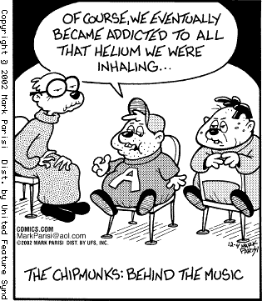

Joke:
An atom walks into a bar …
Bartender: Hi there, what are you looking for?
Atom: Well, I’ve lost an electron.
Bartender: Oh dear, are you sure?
Atom: Yes! I’m absolutely positive.

