Name ________________________________________ Date ___________ Period ____
Moles, Percent Composition, and Empirical Formulas

Use conversion factors and show all of your work in answering the following questions.

- Determine the molar mass of the following compounds.

  - Na₂O₂ c. (NH₄)₂SO₄

  - Mg(NO₃)₂ d. K₂CO₃

- Make the following calculations for AlCl₃.
a. Determine the molar mass of AlCl₃.

b. Calculate the moles of 855.8 grams of AlCl₃.

c. Determine the formula units of AlCl₃ in 0.665 moles.

d. Determine the mass of 2.30 x 10²⁴ formula units of AlCl₃.

Percent Composition and Empirical Formula: Definitions

Percent Composition
The percent composition (by mass) of an element in a compound is the mass of one element in one mole of compound divided by the molar mass of the compound, times 100.

Percent composition of element i | = | mass of i in one mole of the compound | x 100
 |  | mass of one mole of the compound

The molecular formula of a compound gives the exact number of atoms of each element.

The empirical formula of a compound describes the relative number of each type of atom in the compound. It is the smallest-whole-number ratio of elements (as subscripts). For example, the empirical formula of ethyne (in table above) is CH even though the molecular formula is C₂H₂.

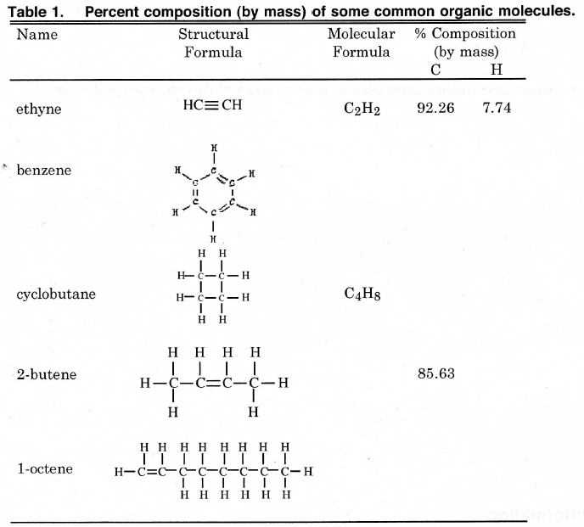
Empirical Formula

CH

Answer the following questions regarding the table above, showing your work for any calculations.

- Fill in the missing molecular formulas and % composition in Table 1.

- Verify that the % composition given for ethyne in Table 1 is correct.

- Is it possible, given the original data in Table 1, to determine the % composition by mass of H for
2-butene without using the given equation for percent composition? If so, how?

- Based on the data in Table 1, is it possible to determine the molecular formula of a compound solely from its percent composition? Why or why not?

- Comment on the ratio of the elements present in all the compounds with the same % composition.

6. Determine the empirical formula of each molecule in Table1. Write it to the right of the molecule in the table.

7. The molecule 2-hexene has the molecular formula C₆H₁₂. Using Table 1, instead of math, determine the percent composition of H in this molecule.

Practice Problems

1. Calculate the percent composition (include each element) for the following compounds.

  - Na₂O₂ b. Mg(ClO₃)₂

c. (NH₄)₂SO₄ d. K₂Cr₂O₇

2. Determine the percent composition of acetic acid, C₂H₃O₂.

- Calcium dihydrogen phosphate is an important fertilizer. What is the percent of phosphorous in Ca(H₂PO₄)₂?

- A 9.03 piece of Mg combines completely with 3.48 g N to form a compound. What is the percent composition of this compound?

- For many years, chloroform (CHCl₃) was used as an anesthetic in spite of the fact that it is also a toxic substance that may cause liver and kidney damage. Calculate the percent composition of CHCl₃.

