Name: _________________________________ Date: __________Period: ____
Energy Forms and Transformations

1. Write a brief definition, make a sketch or diagram, and give an example of each of the following energy forms:
Type of Energy | Definition | Example | Sketch or Diagram
Thermal

Electrical

Nuclear

Chemical

Electromagnetic

Mechanical

2. Below are examples of objects or processes that convert energy from one form to another. Identify the type of energy transformation by filling in the blanks.

Example: light bulb transforms __________________ energy into __________________ energy.

Example: photosynthesis transforms __________________ energy into __________________ energy.

3. With your partner or in your group, come up with 5 different examples of objects or processes that transform energy. Determine the type of energy going in and the type of energy being produced.
Example | Type of energy put in | Type of energy coming out
- The different types of energy may seem to have little in common. However, the broad definition of all of these forms of energy is the ability to…

- Identify the form of energy described in each of the following:
- Energy stored within the nucleus of an atom:

- Energy stored in the bonds between atoms:

- Energy possessed by an object due to motion/vibration of atoms or molecules:
- Each object or process listed below is capable of transforming one form of energy into another. For each object, fill in the blanks with the type of energy the object/process starts with, and the type(s) of energy it produces. Energy types: Electromagnetic, Thermal, Chemical, Nuclear, Electric, Mechanical
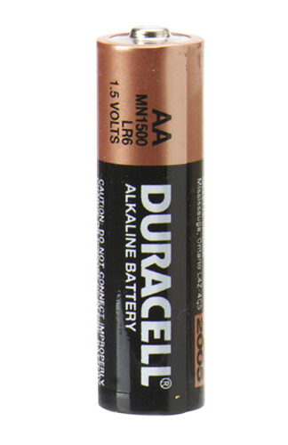
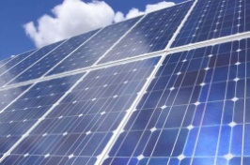
Toaster: ___________________ into ___________________
Battery: ___________________ into ___________________
Gasoline in car: ___________________ into ___________________
The Sun: ___________________ into ___________________
Fire fly: ___________________ into ___________________
Electric Fan: ___________________ into ___________________
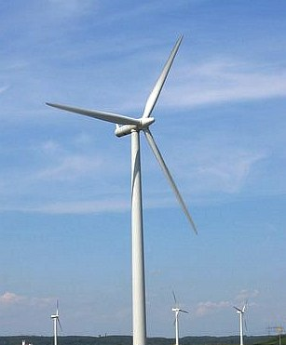
Cellular respiration: ___________________ into ___________________
Wind turbine: ___________________ into ___________________
Light bulb: ___________________ into ___________________

- In all of the energy transformations above, not all of the energy going into the object or process is recovered. Explain why and give an example.

- When a rock is dropped, the rock possesses mechanical energy during its entire fall. But you could still say that as it falls, the rock’s mechanical energy transforms from _______________________ mechanical energy into _________________________ mechanical energy.

