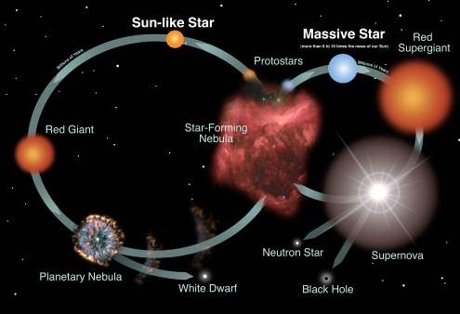
Name ____________________________

Date _____________ Period _____

Essential Question: What evidence do scientists use to explain the nature and origin of the universe?

Directions: Login to the DE techbook using your Google username and password. Open the Earth and Space Science book to the “Universe” unit, “Stars & Galaxies” chapter. As you read the text and watch any videos under the “EXPLORE” tab, answer each of the following questions:

- All Stars release huge amounts of energy during their life cycle. What does the energy get released as and where does this energy come from?

- How are elements formed from stars?

- Why are the elements Hydrogen, Helium, and Lithium so important?

- Describe what happens in order for the birth of a star to occur.

- Explain what happens during the main sequence of a star

- Do all main sequence stars have similar properties? If not, why?

- What phase are all stars in before they begin to die?

- What determines a stars fate before it dies and how? (Color, temperature, mass, element properties?

- Stars that have a small mass go from being a red giant to a white dwarf and then to a black dwarf. Describe this process of a small star’s death.

- What explosion occurs for all stars with larger masses? After this explosion, large stars can either die as a neutron star or a black hole. What is the difference between the two?

