Name____________________________________________________________________Per______Date__________
Geologic Time Scale
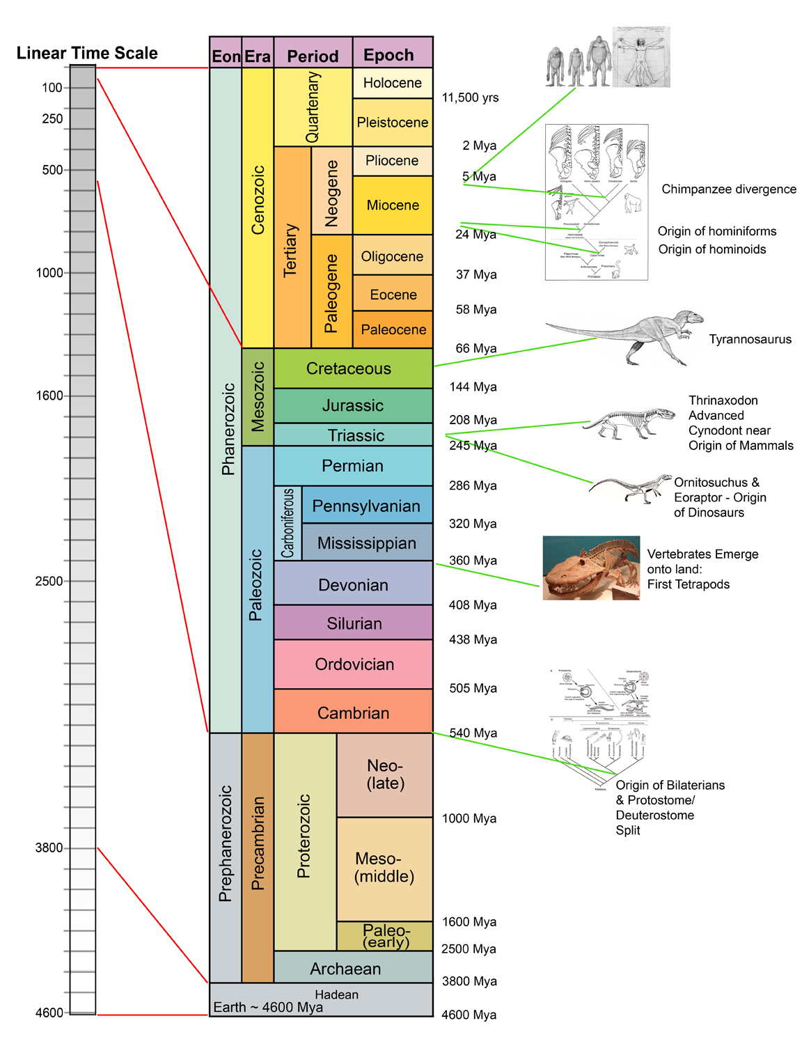

http://www.uprightape.net/Time_Scale4.jpg

