Name _______________________________________________________________ Date ____________
Homeostasis and Hormones – A Lab Simulation
Directions:
- Read through the Background Information and answer the 10 Pre-Lab Questions (you may hand-write your answers on this page).
- Fill out Table 1 before observing the rat autopsy diagrams.
- You will observe the diagrams of seven sets of male laboratory rats (2 rats per set) to help determine the identity of the unknown hormones given to each of the rats.
- Answer the 7 Post-Lab questions.

BACKGROUND INFORMATION:

The organs of the body communicate with each other through the nervous and endocrine systems to coordinate their activities. The nervous system uses neurotransmitters and neurons to convey information to and from the brain. In contrast, the endocrine system uses hormones, which are chemical messengers produced by specific tissues in the body, to transmit information. These hormones travel through the bloodstream to exert their effects on distant target organs.

In a similar manner, people communicate with each other by using telephones and the postal service. The body’s nervous system is comparable to the telephone system because it sends fast, direct messages. The endocrine system is comparable to the postal service because the delivery of the message is slower. Like bulk mail, the message is more diffuse (reaches a greater area) and affects more than one person or organ. Although the hormone travels through the body via the blood, it can only affect those cells with receptors for that specific hormone. Hormones are a slower method of communication, but their effects last longer.

The command center for the endocrine system is the hypothalamus, a small, penny-sized portion of the brain. The hypothalamus acts as an endocrine organ that secretes oxytocin and anti-diuretic hormone (ADH, also known as vasopressin). These hormones travel down the pituitary stalk to the posterior pituitary gland where they are released directly into the bloodstream. In addition, the hypothalamus also regulates anterior pituitary gland function through the secretion of releasing hormones: thyroid-releasing hormone (TRH), corticotropin-releasing hormone (CRH), and gonadotropin-releasing hormone (GnRH).

These releasing hormones travel through a specialized blood vessel system (known as the hypothalamic-hypophysial portal system) that connects the hypothalamus to the anterior pituitary gland. From here, they stimulate the synthesis and secretion of anterior pituitary hormones, which include thyroid-stimulating hormone (TSH), luteinizing hormone (LH), follicle-stimulating hormone (FSH), growth hormone (GH), adrenocorticotropin hormone (ACTH), and prolactin. Each of these hormones is released into the bloodstream to affect specific target organs. For example, the hypothalamus secretes TRH, which travels to the pituitary gland to release TSH; TSH travels to the thyroid gland (the target organ) and stimulates the release of thyroid hormone. It is important to note that the hypothalamic releasing hormones are only required for the synthesis and release of the anterior pituitary hormones. The posterior pituitary hormones are synthesized by the hypothalamus and travel down neurons to be released from the posterior pituitary gland. Because the anterior pituitary gland secretes multiple hormones, it is frequently referred to as the ‘‘master gland.’’ For this experiment, we will focus on the hypothalamus only as a regulator of the anterior pituitary gland. Figure 1 shows the relationship between the hypothalamus and the pituitary gland.

Pre-Lab Questions:

- Describe the relationship between the hypothalamus and the anterior pituitary gland.

- List the hormones released by the anterior pituitary gland.

- Why is the anterior pituitary called the master gland?

- What is negative feedback?

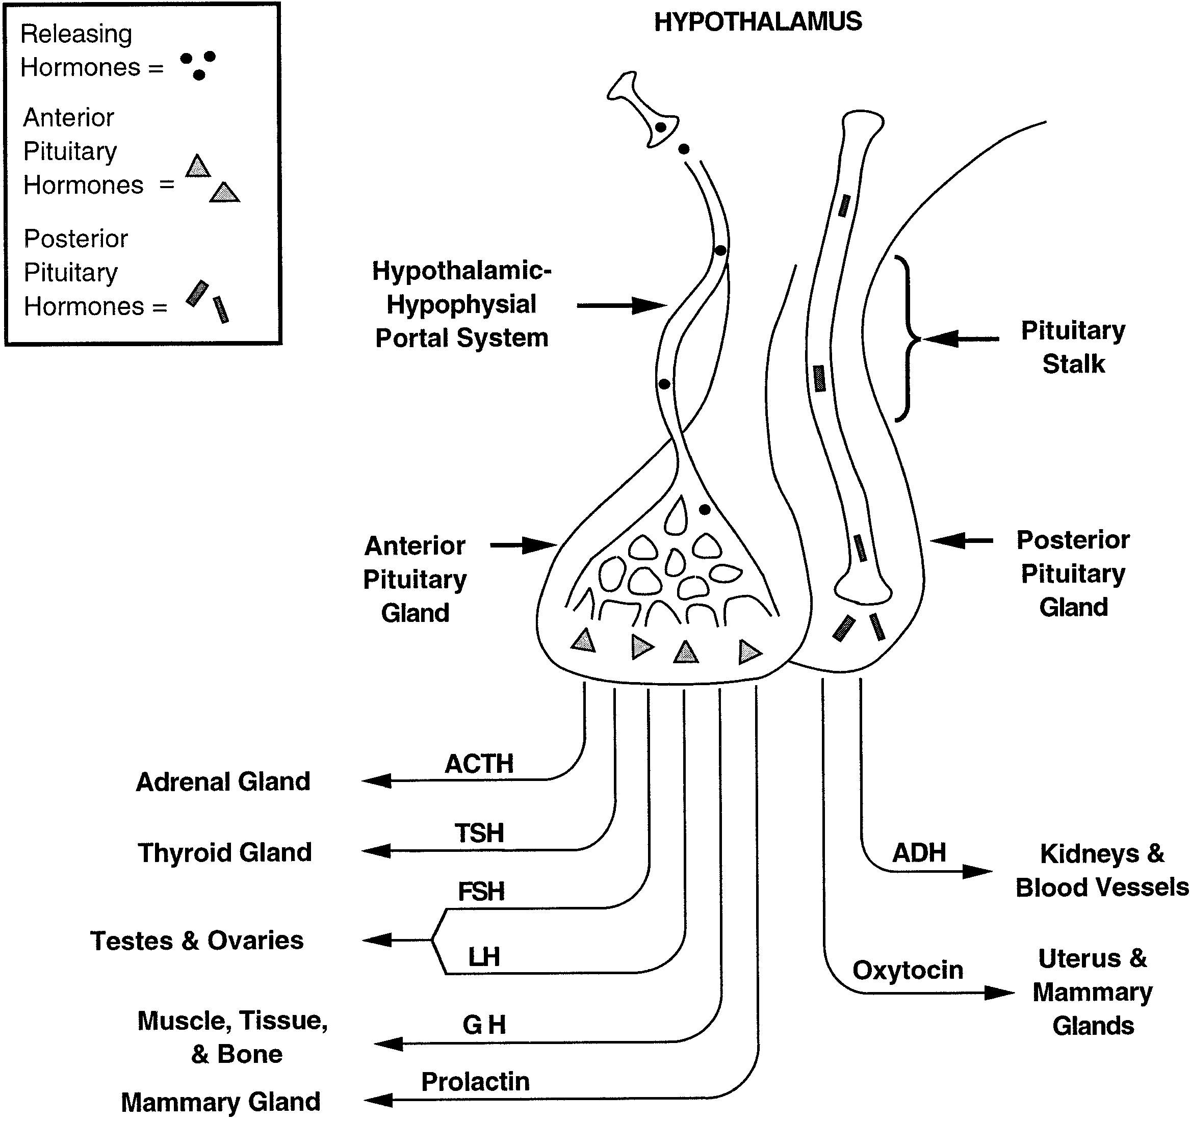
Figure 1: Secretion of hypothalamic hormones. Hypothalamic releasing hormones travel down the hypothalamic- hypophysial portal system to the anterior pituitary gland, where they stimulate the synthesis and release of anterior pituitary hormones [adrenocorticotropin hormone (ACTH), thyroid-stimulating hormone (TSH), follicle-stimulating hormone (FSH), luteinizing hormone (LH), growth hormone (GH), and prolactin]. In contrast, the posterior pituitary gland does not require releasing hormones, because the hypothalamus synthesizes and secretes both anti-diuretic hormone (ADH) and oxytocin.

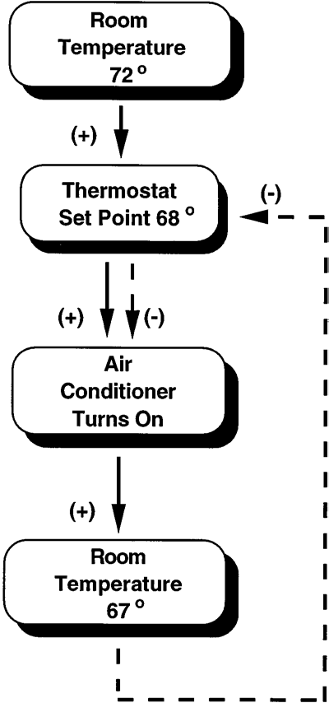
The release of hormones from the endocrine system can be regulated through positive or negative feed- back mechanisms. The negative feedback system can be compared with a thermostat set at a predetermined temperature (68°F). When the temperature rises above the set point (72°F), the thermostat detects the change and activates the air conditioner to cool the room. The thermostat will turn the air conditioner off once the temperature of the room drops below the set point (67°F). To keep the room at a fairly constant temperature, the thermostat assesses the situation and turns the air conditioner on or off accordingly. Figure 2 illustrates the concept of negative feedback using the above example.
In the endocrine system, negative feedback is used to inhibit further hormone secretion. When a sufficient amount of hormone has been released, it communicates or ‘‘feeds back’’ to suppress the releasing organ. In other words, the gland has released enough hormone to fulfill its function; this is sensed by the body, and production of the hormone ceases. Negative feedback not only inhibits the releasing organ, but can also inhibit the pituitary gland and/or hypothalamus. By using a negative feedback system, the body produces only the amount of hormone it needs without wasting its resources. Conversely, in positive feedback, the end product further stimulates the releasing organ. This form of feedback is less common.
The pathways of the three hormones are examined in this experiment: thyroid hormone, cortisol, and testosterone. The hormonal pathways are similar in all three cases. It is important to realize that they hypothalamus secretes a releasing hormone to regulate each of the hormones secreted from the anterior pituitary gland. In this way, the hypothalamus is like a command center. If the hypothalamus is not stimulated, the hypothalamic releasing hormones (TRH, CRH, and GnRH) will not stimulate the anterior pituitary gland to secrete its hormones.
Figure 2: Negative feedback compared with a thermostat controlling room temp. Solid lines and (+) represent an enhancement of activity, whereas dotted lines and (-) represent an inhibition of activity.

The hypothalamus releases TRH, which travels to the anterior pituitary gland via the bloodstream to stimulate production of TSH. TSH travels to the thyroid gland (located by the trachea) to stimulate the production and release of thyroid hormone. Thyroid hormone influences the growth rate of many body tissues and is necessary for proper central nervous system development. Its main function is to increase a person’s basal metabolic rate (BMR) and to increase heat production. An excess of thyroid hormone can negatively feedback to inhibit further thyroid hormone release from the thyroid gland, TSH secretion from the anterior pituitary gland, and/or TRH release from the hypothalamus
Similarly, ACTH is released from the anterior pituitary gland in response to CRH secreted from the hypothalamus. ACTH stimulates the adrenal glands (located on top of the kidneys) to secrete cortisol, which promotes the breakdown of proteins and fats and helps the body adapt to stress. Cortisol functions to provide the body with fuel by breaking down (catabolism) the materials of the body. Under normal conditions, excess cortisol in the bloodstream will negatively feed back to the hypothalamus (to inhibit CRH release), anterior pituitary gland (to inhibit ACTH secretion), and/or to the adrenal gland (to inhibit further cortisol release). The release of CRH is regulated by negative feedback, circadian rhythms, and stress. Cortisol can also act as an immunosuppressive and anti-inflammatory agent. If cortisol is administered in large doses, its immunosuppressive properties will cause the organs of the immune system to shrink. In this experiment, the thymus gland will represent the organs of the immune system.
Pre-Lab Questions:
5. Describe the effects of thyroid hormone.

6. Describe the effects of cortisol.

7. Describe the role of LH in both males and females.

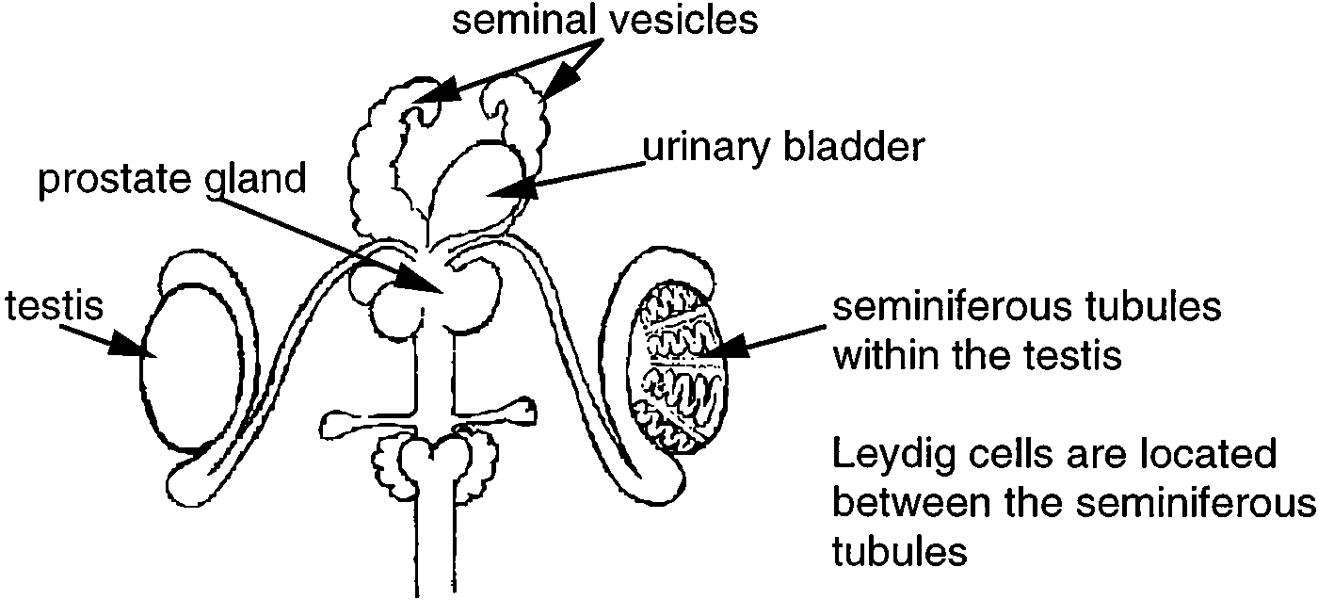
LH is released from the anterior pituitary gland in response to GnRH secreted from the hypothalamus. LH is seen in both males and females but has different functions. In the male, LH travels to the Leydig cells (aka interstitial cells) that are located in the connective tissue between the seminiferous tubules of the testes. The Leydig cells release testosterone, which is responsible for the male sex drive and secondary sex characteristics, such as increased body hair and a deeper voice. An excess of testosterone can cause an increase (anabolic) in muscle mass. Negative effects of testosterone are male pattern baldness and increased secretion of the sebaceous glands, which can lead to acne. Figure 3 presents the relative anatomy of the male reproductive tract.
In the female, LH causes the follicle (developing egg) in the ovary to secrete estrogen. Estrogen participates in either a positiveor negative feedback loop, depending on the stage of the menstrual cycle. In the preovulatory and postovulatory phases, estrogen regulates the release of LH through negative feedback. However, there is a large rise in levels of LH just before ovulation (release of the egg from the ovary) due to a positive feedback mechanism. During this interval, the secretion of estrogen from the follicle further stimulates the release of LH from the anterior pituitary gland. The increased levels of LH are essential for ovulation to occur. Estrogen causes the development of female secondary sex characteristics and sustains the female reproductive tract. A woman who lacks ovaries (and therefore follicles) will not produce estrogen. However, the pituitary gland will secrete excess LH because the feedback inhibition no longer exists. Excess levels of estrogen cause early sexual development in the female as do high levels of testosterone in males.
Figure 3: Organs of the male reproductive tract.

To simplify the relationship between the reproductive and endocrine systems, we will concentrate only on the male system. The female reproductive system is more difficult to study than the male reproductive system because it is continuously cycling. The pathways of all three hormones can be understood by looking at a visual representation in Fig. 4 (Fig. 4 also demonstrates the pathways of the hormones that will be used throughout the experiment, thus serving as an aid in the analysis of laboratory data).
Figure 4: Negative feedback control (hormone pathways). GnRH, gonadotropin-releasing hormone.

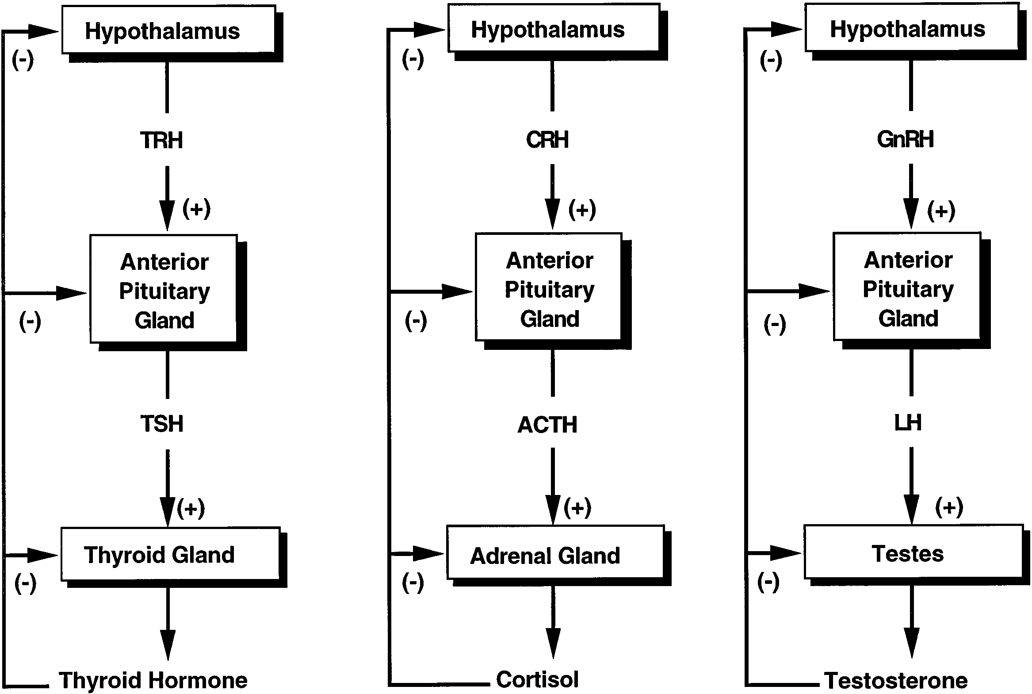
The glands and tissues of our body enlarge (increase in size) if they are continuously activated; this is called hypertrophy. For example, a person who lifts weights will continually stimulate the activated muscles, resulting in hypertrophy. This can be easily observed when comparing a bodybuilder to an average person; the bodybuilder’s muscles appear larger in comparison. In contrast, if a gland or tissue is continuously inhibited it will shrink in size or atrophy. For example, if a cast is placed on a person’s arm for 6 weeks, and then removed, a drastic reduction in muscle mass can be seen. The case prevented any movement (stimulation) of the limb, allowing atrophy to occur.

Pre-Lab Questions:
8. Explain the positive feedback loop observed in LH regulation.

9. Describe the difference between hypertrophy and atrophy.

10. Consider the differences between hyperthyroid- ism and hypothyroidism. What are some characteris- tics of each?

11. What are the effects of decreasing testosterone?

Part 1: Estimating impacts of hormones on specific target organs

Before beginning this activity, use the text in this handout to fill in Table 1.
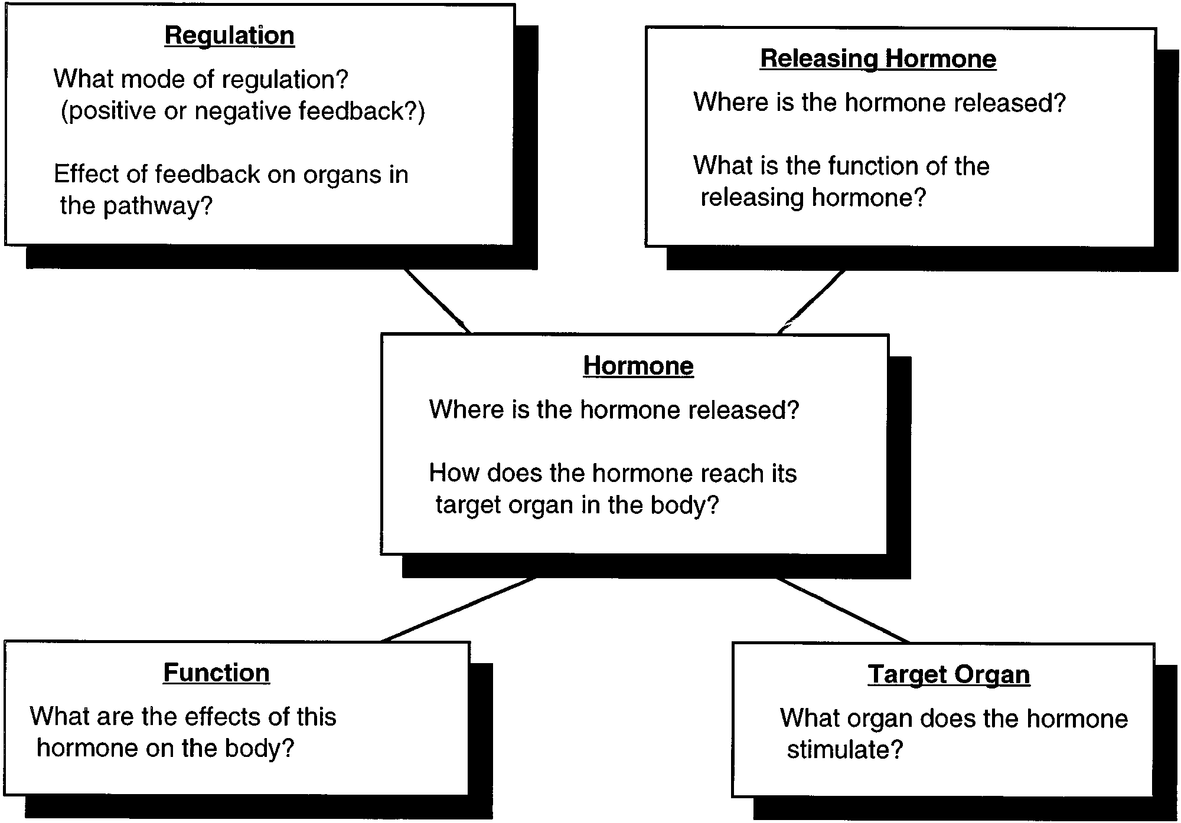

Figure 5: Concept map of endocrine physiology

In this table, you are estimating the impact you think certain hormones will have on the size of target organs. If you think the hormone will cause an organ to increase in size, put a “+” in the box. If you think a hormone will cause an organ to decrease in size, put a “--” in the box. If the hormone does not target the organ, you can leave the box blank. If it DOES target the organ, but causes not change in size, put a “NA” in the box
Table 1: Comparison of hormonal effects on different organs. To fill in this chart, ask yourself, “If I increased the amount of THIS hormone, how would it affect the size of THIS organ?”

Target organ | TRH | TSH | ACTH | Cortisol | Testosterone |  | LH
 |  |  |  |  | Intact | Castrate | Intact | Castrate
Pituitary gland
Thyroid gland
Adrenal gland
Thymus gland
Testes
Prostate
Seminal vesicles
Body weight

Part 2: Determine the identity of the six hormones using the data from the autopsy, as well as Table 1, and Fig. 4.

The data for this laboratory were compiled from seven sets of male laboratory rats, two rats per set; one set is the control group and the remaining six are experimental groups. The rats were all male to simplify the study of the relationship between the reproductive and endocrine systems. In each set of rats there is an “intact” rate and a “castrate” rat. The castration involved removal of the testes to eliminate testosterone production. The two rats (normal and castrate) of each group were treated alike in all other ways (food, water, etc. ). All rats, except for those in the control group were injected with a hormone on a daily basis for 2 weeks. Autopsies were performed on the animals at the end of that time.

The students who performed this experiment were very disorganized and rushed through the work, making errors in labeling the bottles of hormones. The students obtained the following results for organ weights after the autopsies were performed. In this short period of time, the students noted drastic changes in the size of certain organs when they compared the experimental group of rats with the control group. Using the flowchart (Fig. 4), Table 1, and the autopsy data, match the unknown rat groups with their respective hormones. The bottles of unlabeled hormones included ACTH, cortisol, LH, TSH, TRH, and testosterone.

To help in determining the identity of the unknown hormones, look for changes between the control values and the values after treatment with the unknown hormone (both intact and castrate animal). The changes between the control rats and the rats that were treated with the unknown hormone should be greater than 20% if they are to be considered significantly different. If the change is less than 20%, it is attributed to experimental or biological error. Experimental error may include small errors in calibration procedures, measurements, or instrumentation. Any variability that occurs because of the differences between animals is considered biological error.

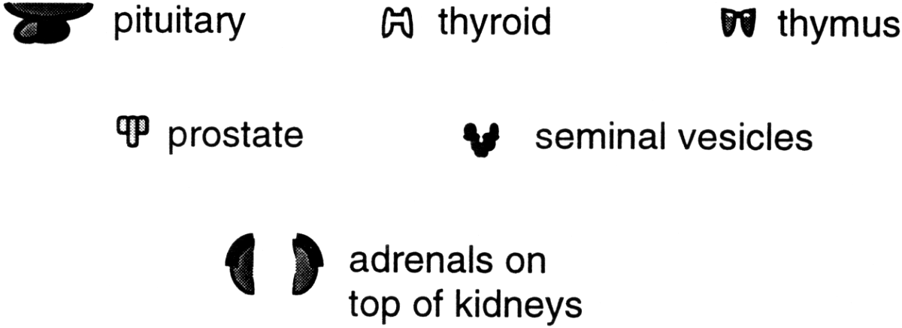
Figure 6: Graphic representation of organs studied in the autopsy.

Post-Lab Questions:
1. What was hormone 1? Explain your answer.

2. What was hormone 2? Explain your answer.

3. What was hormone 3? Explain your answer.

4. What was hormone 4? Explain your answer.

5. What was hormone 5? Explain your answer.

6. What was hormone 6? Explain your answer.

7. Evaluate the lab investigation like you would for any IB IA lab practical. What changes or improvements (if any) should be made?

