Name ________________________________________ Date _______________ Period ______
Integrated Science 1: Review for Final Exam – Fall 2015
Answer all of the following questions, review your labs, quizzes, and test reviews, study your glossary, and organize your binder to prepare for the final exam.

History of the Universe
- An analogy for the formation of our universe is a rising ball of dough with raisins in it. As dough rises, the raisin spread out. Explain why this might be a good analogy.

- Describe how the big bang occurred and provide one piece of evidence that supports it.

- Einstein’s famous equation, E = mc², relates mass to energy. Explain how this equation relates to events in the Big Bang.

- Put the following in order from smallest to largest.
Sun, Milky Way galaxy, Saturn, universe, moon, Betelgeuse (red giant), Earth

- Write the phases in the life cycle of a star in the correct order in the boxes below.
Include main-sequence star, nebula, red giant, neutron star, white dwarf

PROTOSTAR

Write the characteristics of each phase in the box.
Include characteristics such as: size, abundant elements,
rate of fusion, etc.

NEUTRON STAR

BLACK HOLE

- Explain how a star produces heat energy and light energy. Include the terms hydrogen, helium, fusion.

History of Earth
- Use the boxes, and lines, below to diagram the characteristics of the three types of rocks and explain how they are formed.
- Write a type of rock and its characteristics in each box.
- Describe how one type of rock is converted to another on the arrows between the boxes
- The process that occurs to convert one type of rock to another type of rock.

- Describe how intrusive and extrusive igneous rocks are different in terms of where they form and their characteristics.

- Describe how energy is involved in changes from one rock type to another.

- Interpreting Rock Layers
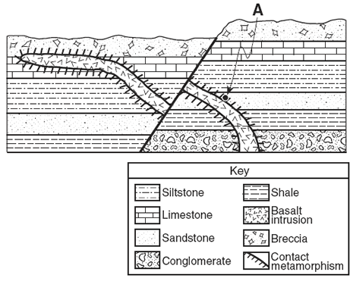
- State the Law of Superposition.

- The diagram at the right shows 7 types of rock.
Put the layers in order of oldest to youngest
by type of rock.

- Explain how a scientist could determine the relative age of a rock layer. What is the relative age of the shale?

- Explain how a scientist could determine the absolute age of a rock layer.

- Look at the diagram below of air over water and land.
- Explain why the surface of the water and air above it would be cool, while land and the air over land is warm.

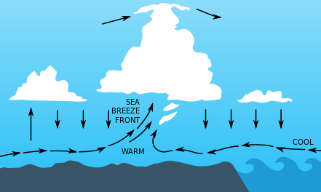
- Name the process that causes warm air to rise and cool air to sink and sketch a diagram.

c. Explain how this same process causes movement in the mantle of the Earth.

- Identify at least 4 (four) sources/reservoirs of carbon.

- Compare removal of Carbon from the atmosphere with addition of Carbon to the atmosphere. Explain why it is not equal.

- Explain how the light energy from the sun interacts or is transformed as it moves through layers of the atmosphere. Include a reason for the global warming in the troposphere.
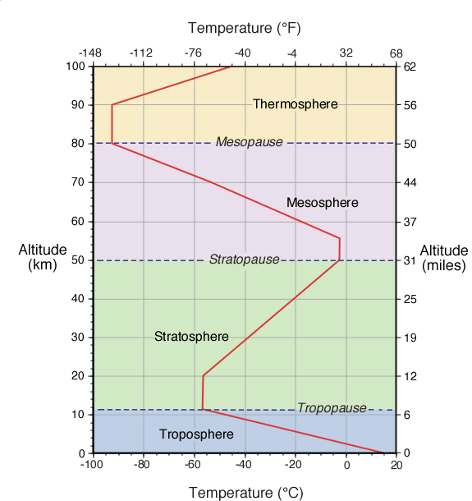

- Identify a form of energy represented in each of the following and explain your answer.
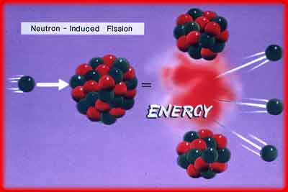

- Each object or process listed below is capable of transforming one form of energy into another. For each object, write the type of energy the object/process starts with and show transformations to the type(s) of energy it produces. Energy types: Light, Thermal, Chemical, Nuclear, Electric, Mechanical
Car engine:
Solar panel:
g = 9.8 m/s²
1 kg = 2.2 pounds
1 ton = 2000 pounds
1000 J = 1 kJ
Wind turbine:

- Convert 15 kg to tons.

- Determine the potential energy (PE ) for a 2.0 kg rabbit that sits on the edge of a log that is 0.75 m above the forest floor.

- Calculate the work a crane does raising a girder using an average force of 380N to lift the girder 12m.

- Mowing a lawn requires pushing a mower with a force of 48N across a lawn a total of 95m. Determine the work used to mow the lawn.
- Calculate the power output if the job takes 300 seconds.

- Using a jack a mechanic does 7.350 kJ of work to lift a car onto a platform in 80 sec. Calculate the power output.
  - Use a conversion factor to convert kilojoules (kJ) to Joules (J)

  - Calculate the power the jack does on the car.

- A kid lifts a 2.6 kg hedgehog into its cage, which sits a distance of 1.1m above the ground. It takes the kid 2.5 seconds to complete the job. How much power is required to do this?

- A student decides to test how the angle of the wind turbine blades affects the power a turbine can generate. She measures the mass lifted and the time it takes to lift the mass while keeping the height the same.
  - Identify the independent and dependent variable in the investigation.

  - Identify at least 2 variables that should be held constant.

- Identify, on the diagram below the following layers of the earth’s interior.
Describe the temperature and density of each layer as high or low.
  - Mantle
  - Lithosphere (crust)
  - Inner core
  - Outer core
Use labels and arrows to show where the lithosphere and
mantle fit into the layers.

Describe how the lithosphere and asthenosphere are different.

- Draw 3 labeled diagrams of the different plate boundaries.
On each diagram include:
- Arrows showing plate movement
- Features associated with that plate boundary (trench, volcano, ridge, earthquake)
- Identify location of solid rock and molten rock (if present)
- Label subduction zone and spreading zone (if present)

  - Convergent boundary:

  - Divergent boundary:

  - Transform fault:

- Read the article below and complete the prompts.
An Arctic Volcano
Scientists have discovered an active volcano buried more than a half-mile beneath Antarctica, raising the idea that another force besides global warming could one day contribute to the melting of the polar ice sheet. The researchers were studying the structure of the Earth’s mantle when they encountered unusual data showing two areas of low-magnitude earthquakes in western Antarctica in 2010 and 2011. The earthquakes occurred at a depth of 15 to 25 miles. Seismologists, scientists who study seismic waves from earthquakes, say the vibrations resemble the waves from Deep Long-Period earthquakes, which have been recorded in active volcanic regions of Alaska’s Aleutian Islands and the Pacific Northwest. They realized that the seismic waves were due to volcanic activity. “At some point this volcano is going to erupt,” said Amanda Lough, a graduate student at Washington University. While any eruption is unlikely to break through the half-mile-thick ice above the volcano, magma flow could cause serious ice melting in the western Antarctic and raise sea levels worldwide.
- Identify the topic in a few words. _________________________________________________________
- Summarize the author’s claim about the topic in one sentence. Include the title of the article and explain what the author is telling us about the topic.

- Summarize 2 or 3 important reasons/evidence that supports the main idea. Use specific details from the article.

Extent of Arctic Sea Ice over 12 months
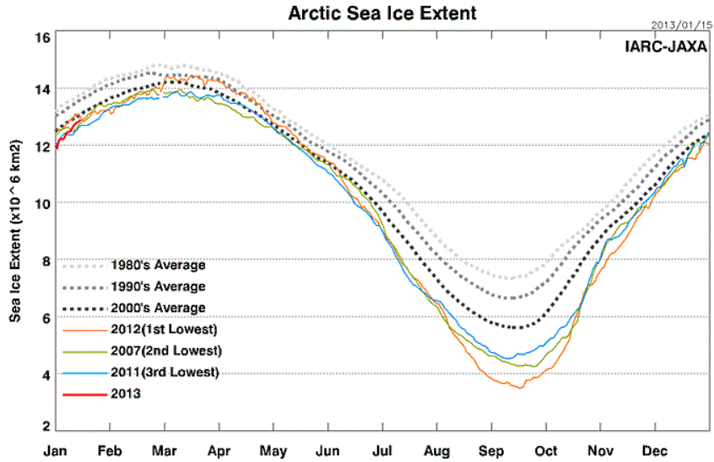
d. In which month is the extent of sea ice the greatest?

e. In which years was the extent of sea
ice the greatest?
The lowest?

f. Why do you think it has changed? Refer to the graph to explain.
Time (months)

