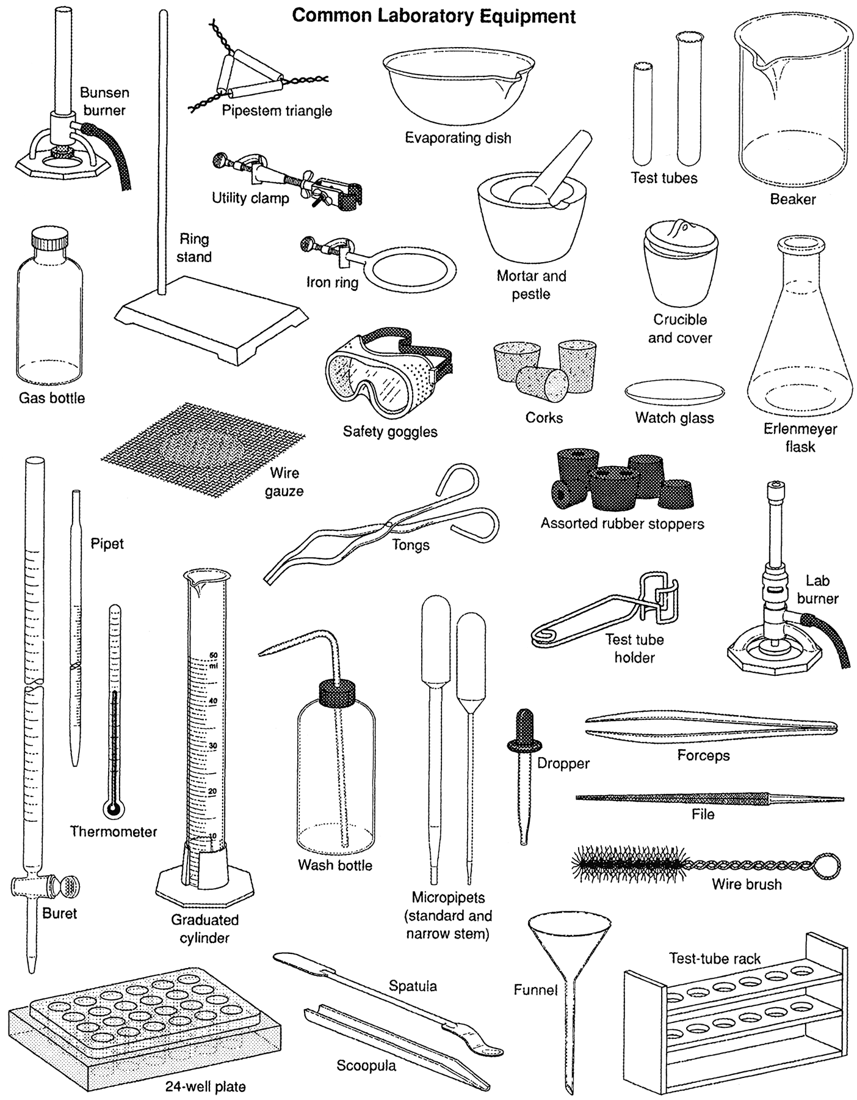

Name __________________________________________ Date _______ Period ______
Laboratory Equipment
Part 1: Identify the type of laboratory equipment, identify the intended use, and record the degree of uncertainty and measurement of object (include units for both uncertainty and measurement) in the table below.
Equipment | Name | Use | Uncertainty | Unit
Station 1

Station 2

Station 3

Station 4

Station 5

Station 6

Station 7

Station 8

1.
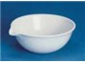
2.
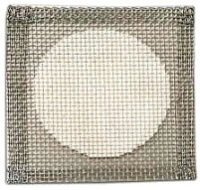
3.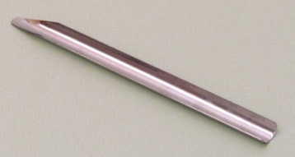
4.
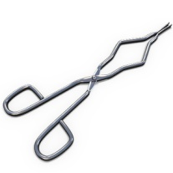
Part 2
Answer the following questions in complete sentences.

- Which lab station container(s) from Part 1 is (are) appropriate to use in measuring volume of liquids? Explain your reasoning.

- Which lab station containers from Part 1 are good for mixing or heating solutions, but are not good for measuring volume? Explain your reasoning.

- Why is picture 3 from Part 1 not an acceptable item to be used for stirring solutions?

- Briefly explain the rule for determining the uncertainty of laboratory equipment in chemistry.

