Unit 1: Learning Goals for Energy in the Biosphere 1

Big Picture: Students should understand how position of the Earth, climate, and factors such as latitude, elevation, or geography affect the biotic and abiotic factors in a given area.
Content Goals |  | Skills Goals
Students will know how to:  - Identify biotic and abiotic factors in an ecosystem  - Explain how the position of the Earth (tilt of the axis) affects the seasons / climate  - Discuss the effect of: latitude, elevation, proximity to water, topography, humidity, and wind on climate  - Determine most likely biome based on latitude and climate factors of an area  - Predict type of climate for given biome  - Identify common plants and animals in various biomes  - Describe interactions between abiotic or biotic and factors in an ecosystem or biome  - Identify parts of a microscope and describe their functions  - Describe characteristics of organisms in each kingdom  - Classify a variety of living organisms by kingdom |  | Students will be able to:  - Support scientific explanation with a reliable source  - Properly cite the reliable source  - Write an APA bibliography for the source  - Make wet mounts of micro-organisms and use microscope properly to view them  - Make detailed sketches of organisms viewed under the microscope and label with appropriate scale
Assessment: How will mastery of content and skills be assessed?
- Show understanding on quizzes and tests
- Write a well-organized paragraph with properly cited sources (biome poster, organism report)
- Write an APA – style bibliography (biome poster, organism report)
- Complete detailed sketches of micro-organisms

Key Vocabulary:  Abiotic  Biotic  Latitude  Climate  Elevation  Humidity  Ecosystem  Community  Population  Organism | Flora  Fauna  Biome  Tundra  Temperate Rain Forest  Tropical Rain Forest  Taiga  Grassland  Savannah  Desert  Chaparral |  | Archaebacteria  Eubacteria  Plant  Animal  Protist  Fungi  Coarse focus  Fine focus  Stage  Objective lenses  Diaphragm

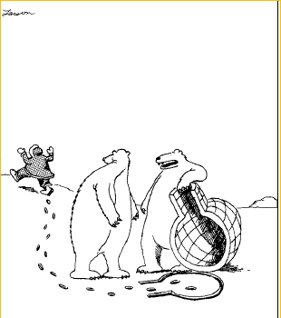
“I lift, you grab … Was that concept just a little too complex, Hal?”

