Unit 1 Learning Goals – Laboratory Safety, Measurement, and Conversions
Big Picture: Students should understand the basic laboratory safety precautions, measurement practices, and methods for making calculations used by scientists.
Content Goals |  | Skills Goals
Students will be able to:  - Identify laboratory behavior as safe or unsafe  - Distinguish between quantitative and qualitative descriptors  - Identify physical and chemical properties of a substance  - Select the appropriate laboratory equipment for a given purpose  - Identify SI units for mass, volume, length, time, and temperature  - Use the basic metric prefixes in converting numbers  - Evaluate accuracy and precision of measured values and calculated values  - Determine the correct degree of uncertainty for standard laboratory equipment  - Convert numbers from standard notation to scientific notation and from scientific notation to standard notation  - Identify the significant figures in a number  - Round calculated values to the correct number of significant figures  - Determine the correct number of significant figures in a calculated value  - Use the factor label method to convert from one unit to another  - Calculate the density, mass, or volume of a sample using the formula: D = m/v  - Calculate the percent error using experimental and theoretical values |  | Students will be able to:  - Conduct laboratory investigations in a safe and productive manner  - Use standard laboratory equipment to accurately measure quantities  - Record measured values with the appropriate uncertainty  - Present data in well-organized tables  - Graph data appropriately  - Interpret graphed data to determine relationships  - Cite source to support hypothesis
Assessment: How will mastery of content and skills be assessed?
Laboratory behavior and student lab reports will show if students can:
- Work safely in the laboratory
- Use laboratory equipment properly
- Prepare well-organized data tables, and make informative graphs
Quizzes and tests will show if students have mastered the content goals.
Key Vocabulary:  Physical property  Chemical property  SI Units  Qualitative | Quantitative  Accuracy  Precision  Degree of Uncertainty  Significant figure | Density  Percent error  Theoretical value  Experimental value  Conversion factor

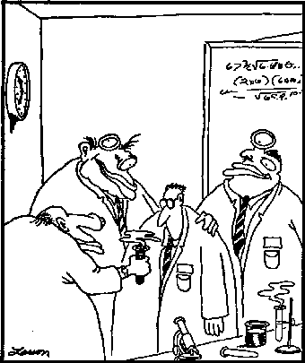
Laboratory Peer Pressure

