Unit 5: Learning Goals for Moles in Compounds, Stoichiometry and Limiting Reactants

Guiding Question: How do scientists predict or determine amounts of reactants and products in chemical reactions?

Content Goals  Students will be able to:  - Determine the molar mass (formula mass) of an element or compound  - Determine the percent composition of a compound  - Determine the empirical formula and molecular formula based on mass of elements or % mass of elements in compounds  - Convert moles to grams or particles AND convert grams or particles to moles  - Write balanced equations for chemical reactions  - Use mole ratios in a balanced equation to determine the moles, mass, or particles of a reactant or product  - Determine the limiting reactant and the excess reactant in a reaction  - Calculate the theoretical yield based on the limiting reactant  - Determine the percent yield from the actual and theoretical yields | Skills Goals  Students will:  - Conduct laboratory investigations in a safe and productive manner  - Use standard laboratory equipment properly to observe various chemical reactions  - Make measurements to the correct degree of uncertainty  - Present data in organized tables  - Present calculations in organized format  - Analyze results of investigation in a written conclusion  - Evaluate the effect of error on experimental results  - Suggest realistic improvements to obtain more accurate results
Big Ideas
Students will:
- Understand how to determine the amount of product that will be produced or the amount of reactant that reacted based on a measured amount of any reactant or product in a chemical reaction

Assessment – How will I know if students have mastered content, skills, and big ideas?
Students will:
- Collect and present data in tables or graphs
- Make calculations and present in organized format
- Complete tests and quizzes on all topics in content goals

Key Vocabulary
Mole  Molar mass (Formula mass)  Coefficient in balanced equation  Subscript in chemical formula  Percent composition  Empirical formula  Molecular formula (compound formula)  Balanced Equation |  | Mole ratio (from balanced equation or chemical formula)  Stoichiometry  Limiting reactant  Excess reactant  Theoretical yield  Actual yield  Percent yield
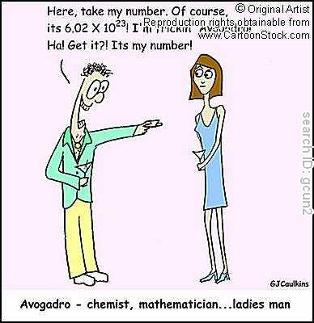
Related in Discovery Ed:
Chapter 10, p. 290-299 mole review
Chapter 10, p. 305-312 % comp, emp formulas, molec formulas
Chapter 11, p. 321-339 Balancing and Writing equations
Chapter 12, p. 353-375 Stoichiometry and Limiting Reactants
Here take my number. Of course it’s 6.02x10²³!
I’m frickin’ Avogadro! Get it?! It’s my number!

