Name____________________________________________________________Per______Date________
Observing Onion Cells: Mitosis Lab Integrated Science 2

You will be observing onion cells in an onion root tip and identifying different stages of mitosis. In a growing plant root, the cells at the tip of the root are constantly dividing to allow the root to grow. Because each cell divides independently of the others, a root tip contains cells at different stages of the cell cycle. This makes a root tip an excellent tissue to study the stages of cell division.
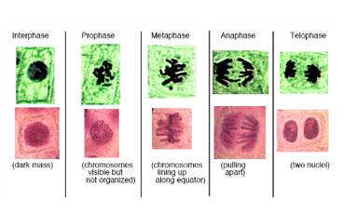
Figure 1. Mitosis in plant cells (above) and animal cells (below).

Pre-lab. Answer the following.

- Why do cells divide (go through mitosis)?

- Why is the tip of a root a good place to observe cells in the different stages of mitosis?

- Which stage of the cell cycle do cells spend most of their lives in? ___________________________

- When cells are in this stage (from #3 above) what are they doing?

- How are the 2 new cells made at the end of mitosis similar? How are they different?

Look at the onion root tip pictures. Complete the following. Label the chromosomes/ nucleus in your drawings (where applicable). SHOW YOUR WORK for calculating the % of cells in each stage.

Title (you complete)_____________________________________________________________________
Phase | Detailed Drawing | Questions to Answer
Interphase  Total # of cells in picture _________ |  | Describe the contents of the nucleus.  How many cells are in interphase? ___________  % of cells in interphase?
Prophase  (circle or highlight EACH cell in the picture that is in this stage in RED) |  | Explain why chromosomes can now be observed, but were not observable during interphase.  How many cells are in prophase?_____________  % of cells in prophase?
Metaphase  (circle or highlight EACH cell in the picture that is in this stage in BLUE) |  | Describe the location of the chromosomes.  How many cells are in metaphase? ____________  % of cells in metaphase?
Anaphase  (circle or highlight EACH cell in the picture that is in this stage in GREEN) |  | Describe what is occurring to each chromosome pair during anaphase.  How many cells are in anaphase? _____________  % of cells in anaphase?
Telophase  (circle or highlight EACH cell in the picture that is in this stage in YELLOW) |  | What cell parts begin to reappear during this phase?  How many cells are in telophase? _____________  % of cells in telophase?
Cytokinesis  (daughter cells) |  | Explain how the number of chromosomes found in each daughter cell compares to the number found in the original cell before mitosis.
Microscope Onion Root Tip
Find and draw a cell showing each stage of mitosis.
- Be sure to include the total magnification used.
- Draw exactly what you see in your field of view.
- Use a highlighter to identify the cell that is either in Prophase, Metaphase, Anaphase, or Telophase.

Prophase Metaphase
Total Magnification: _________ | Total Magnification: _________

Anaphase Telophase
Total Magnification: _________ | Total Magnification: _________

