ONION ROOT TIP MITOSIS
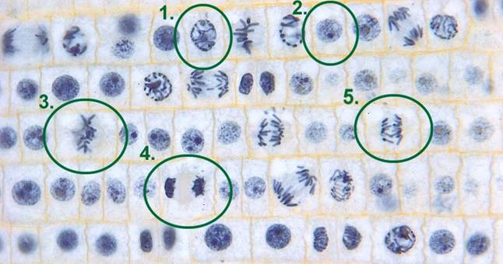
Examples:
- Prophase
- Interphase
- Metaphase
- Telophase
- Anaphase
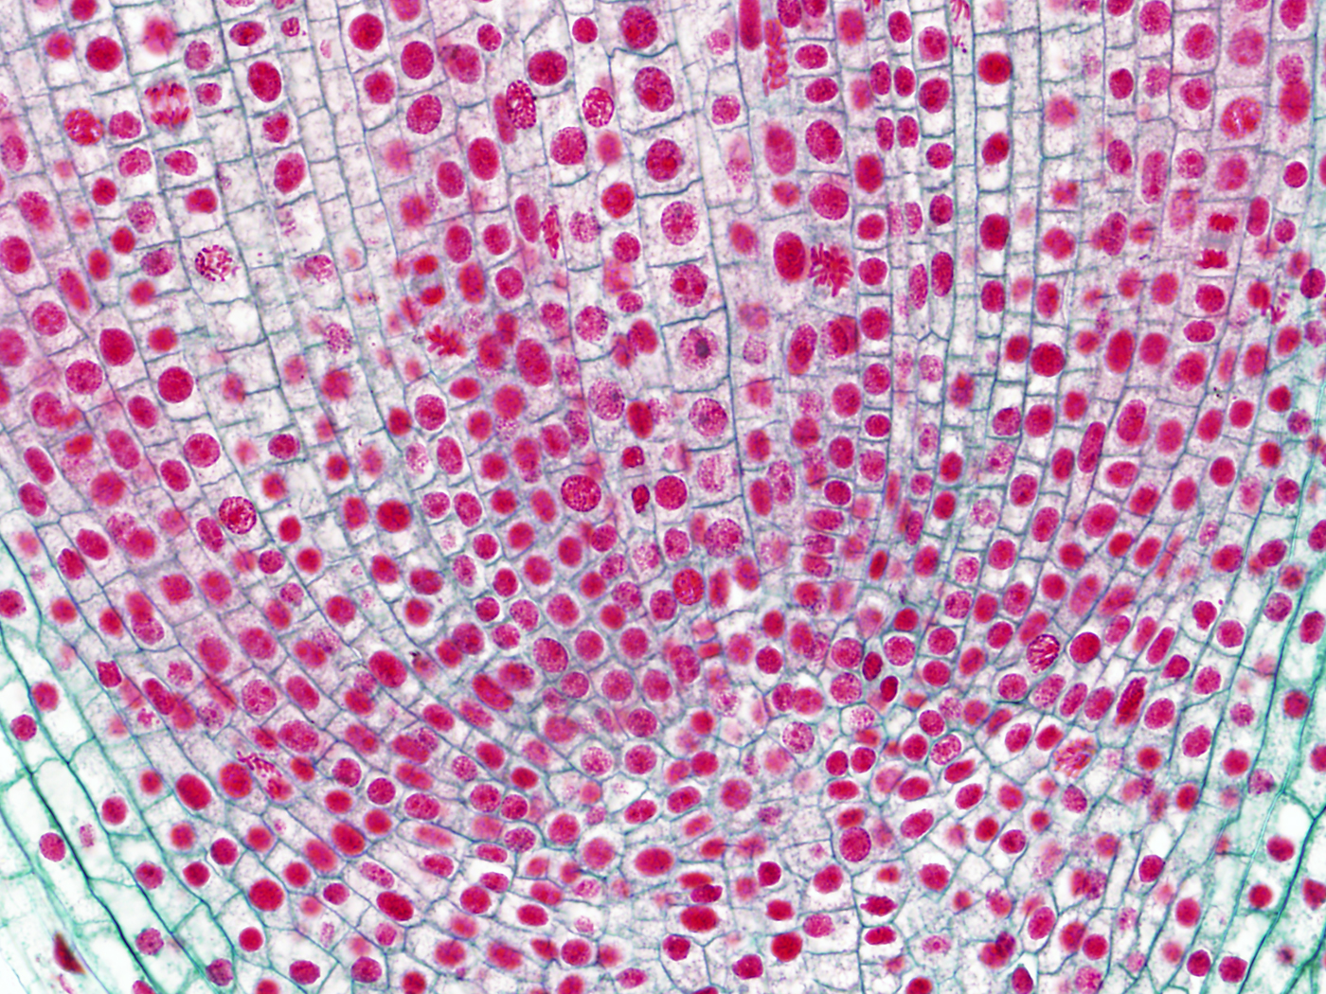Page 2

