Name ____________________________________ Per_______ Date Due _________
Unit 2: Geosphere and Plate Tectonics
You will be conducting independent research to determine why the surface of the Earth is constantly changing. This research will include discovering the factors that change the geosphere, the energy that drives those changes and, of course, how that energy is transferred. A significant portion of this information will be found in your Discovery Education Techbook, under the Course: Earth and Space Science, Unit: Plate Tectonics and Earth’s Internal Structure.
As you complete this packet make sure that you:
- Organize your thoughts, and then write them neatly in the space provided
- Omit spelling or grammatical errors
- Properly cite all sources used in the work cited section on the last page
- Label all drawings
What is the geosphere? (Include specific details)

Make a labeled diagram AND describe the Earth’s Layers
Label the layers in the diagram. Include approximate temperature, density, composition, and one additional fact in each description (go to the Concept: Earth’s Interior, click on the Explore tab, click on Explore More Resources, go down to the” Interact” box, click on Earth’s Interior exploration).
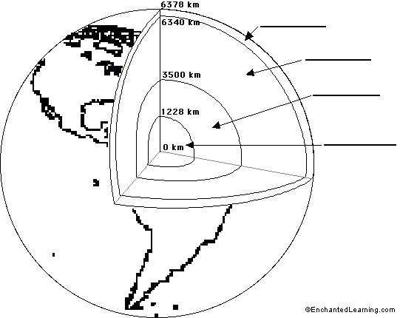

m

(Asthenosphere and mesosphere)

Describe the Theory of Plate Tectonics/Continental Drift (Wegener/Hess)
(go to the Concept: Continental Drift Hypothesis, click on the Explore tab, read How did the hypothesis of continental drift explain evidence of changes in Earth’s crust?)
Theory:

Include at least 3 examples of scientific evidence for this theory.

*

*

*

Explain the cause of movement of the Earth’s plates and describe how energy is transferred through the geosphere. (go to the Concept: Earth’s Interior, click on the Explore tab, click on Explore More Resources, go down to the” Interact” box, click on Earth’s Interior exploration).
Include:
- type(s) of energy and source(s) of energy that drive plate tectonics
- how this energy causes movement of the mantle and plates
- labeled diagram

There are three main types of plate boundaries. Describe how the Earth’s crust moves at each of these types of boundaries and the features associated with that movement.
(go to the Concept: Tectonic Plate Interactions, click on the Explore tab, read What are the three main types of plate boundaries?)
You MUST include:
- diagrams of the three types of plate boundaries with arrows indicating direction of movement
- an example of where on Earth each boundary can be found
- the evidence that supports this.

Describe how plate tectonics affected: evolution, ocean currents and global warming.
(go to the Concept: Tectonic Plate Interactions, click on the Explore tab, go to page 3, read How has plate tectonics affected evolution, ocean currents, and global climate?)

*

*

*

Explain how the processes of the geosphere demonstrate the Laws of Conservation of Matter and Energy. In other words, how are matter and energy conserved through geophysical processes?
Include specific examples of how matter and energy change but are conserved.
Conservation of Matter:

Conservation of Energy:

Works Cited – Include all references you used to complete the information in this packet.
- Use the proper APA format (See APA hand out or Easybib.com to help with formatting)
- Sources should listed be in the order they were used in the packet.

