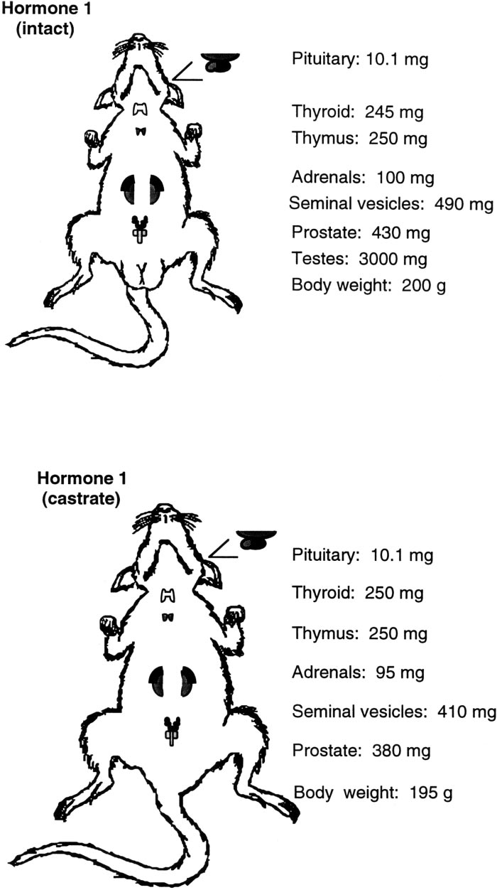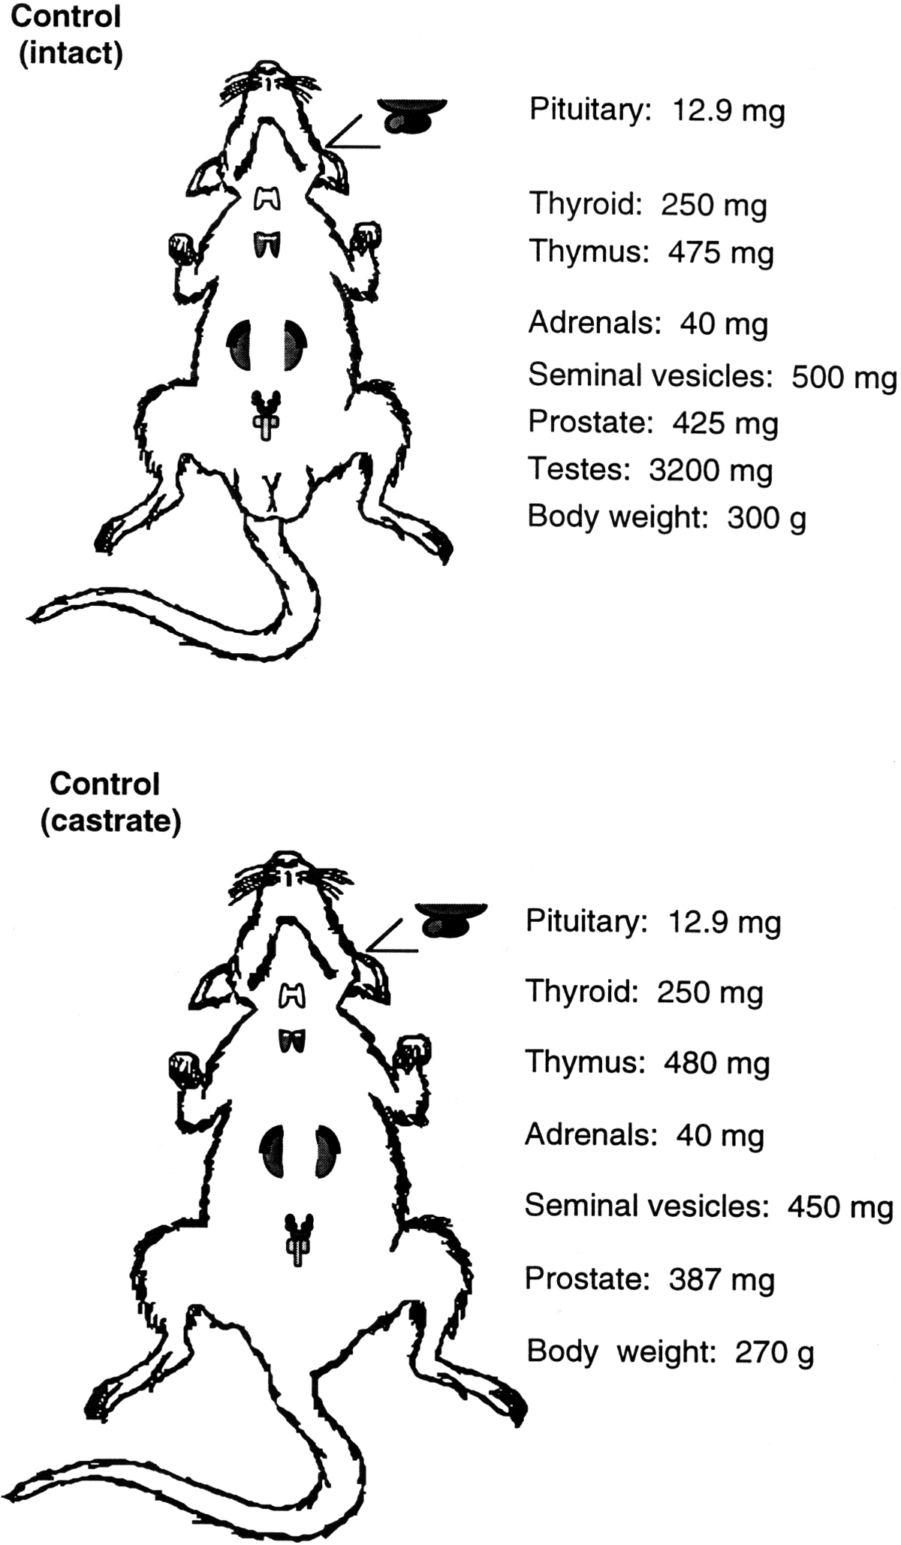

Figure 7

Autopsy results from control rats

Figure 8

Autopsy results from rats treated with *Hormone 1*

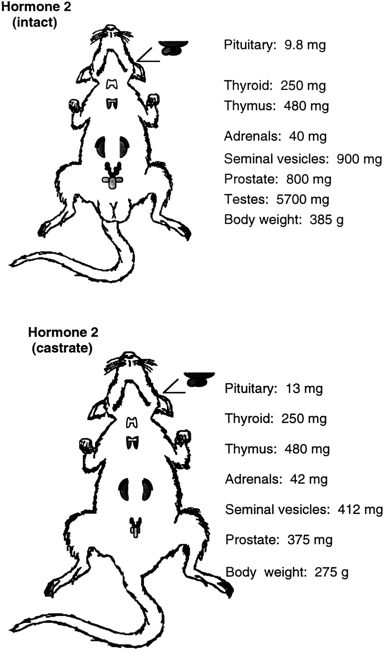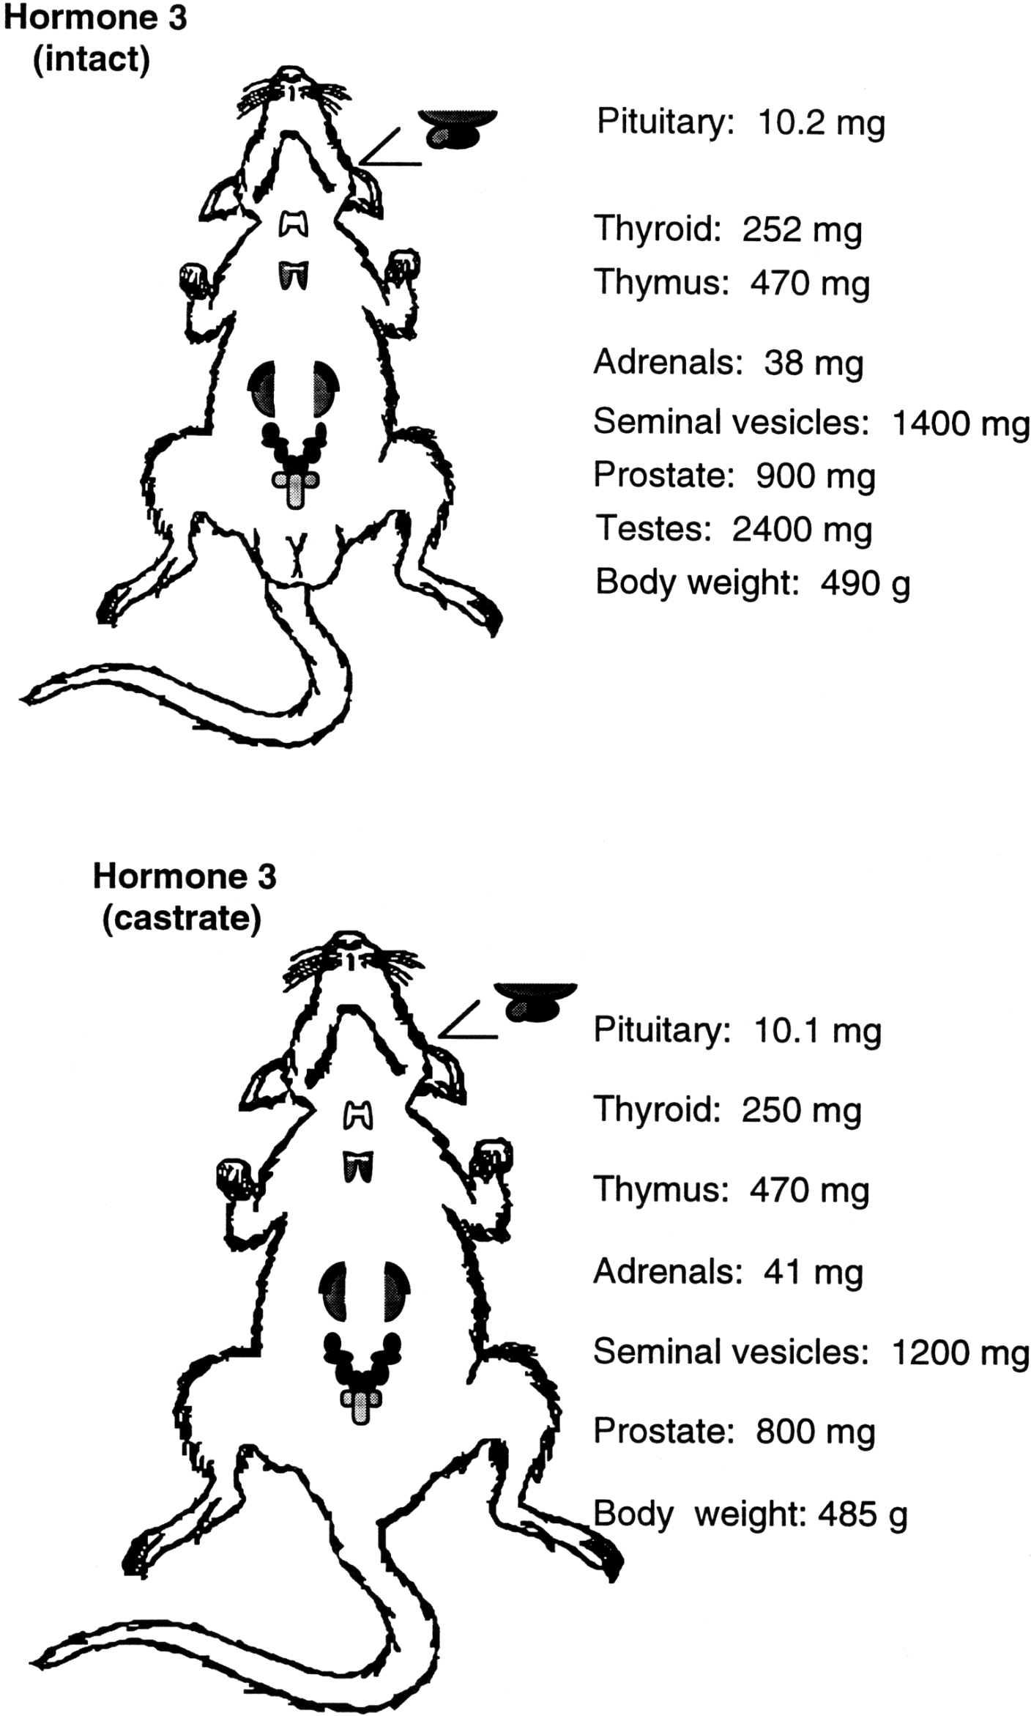

Figure 10

Autopsy results from rats treated with *Hormone 3*

Figure 9

Autopsy results from rats treated with *Hormone 2*

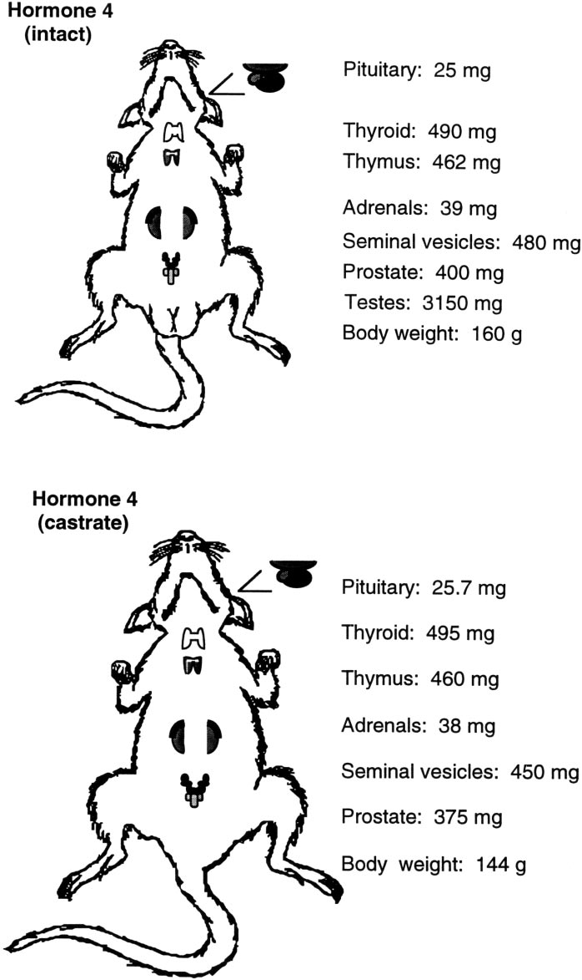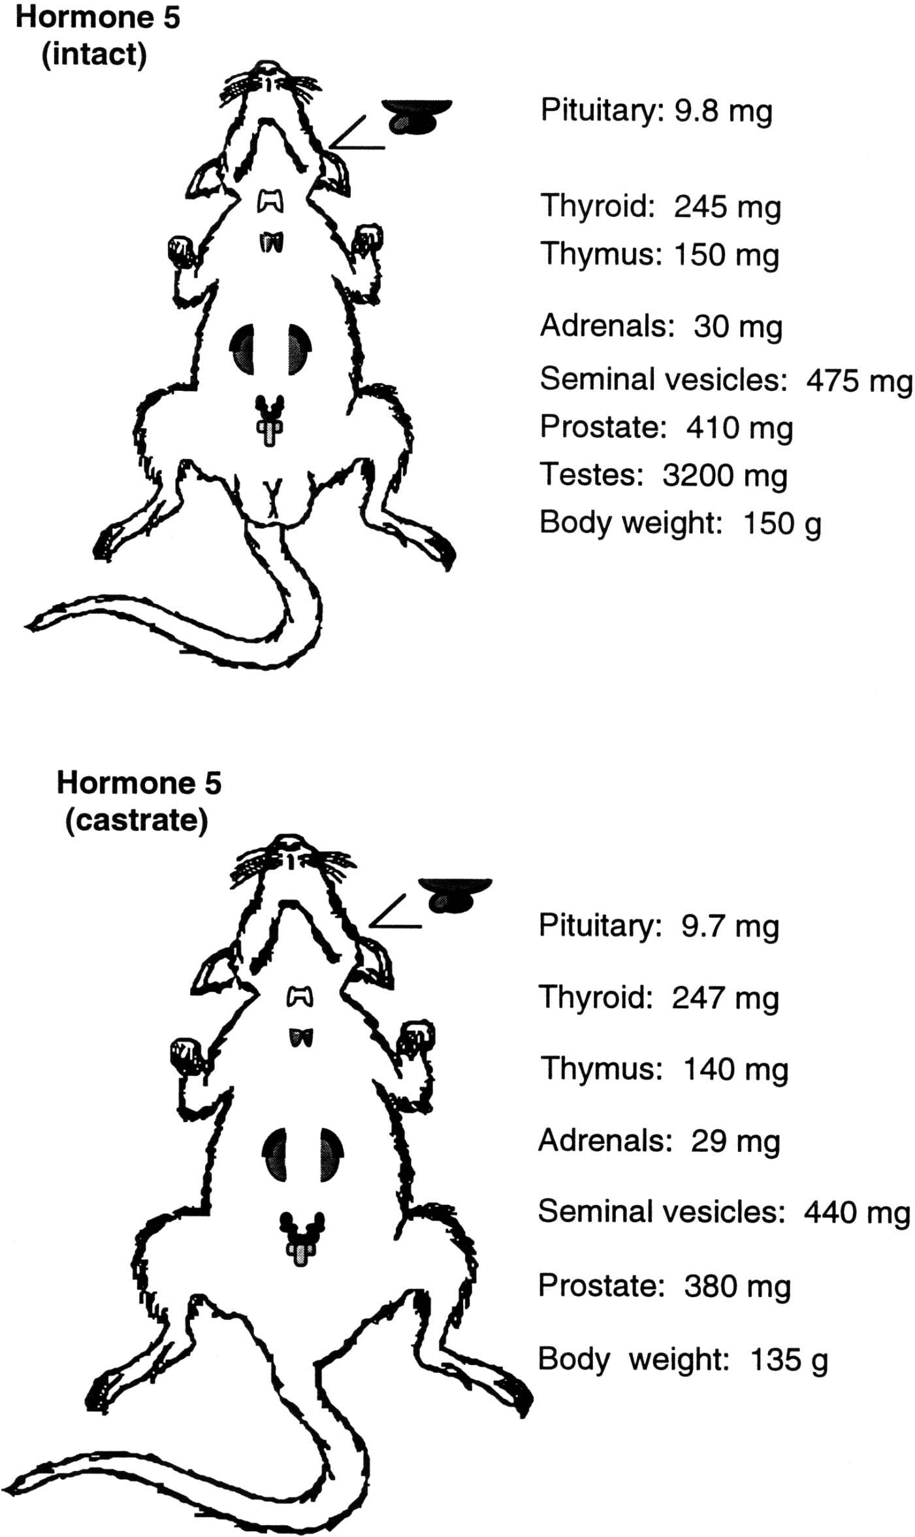

Figure 12

Autopsy results from rats treated with *Hormone 5*

Figure 11

Autopsy results from rats treated with *Hormone 4*

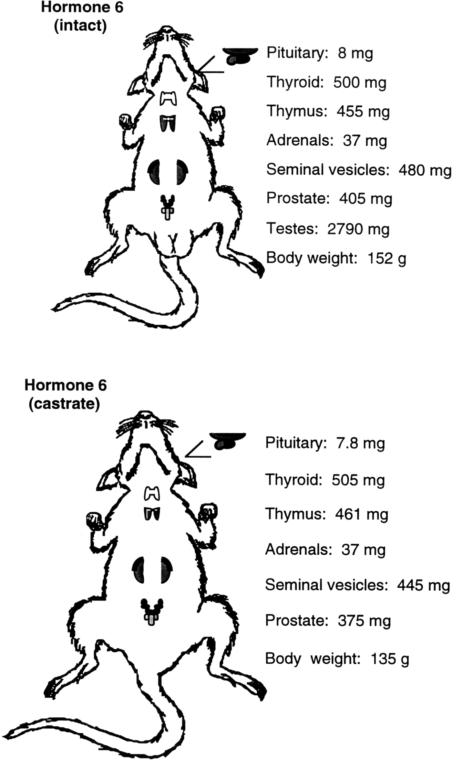

Figure 13

Autopsy results from rats treated with *Hormone 6*