Name________________________________ Date ____________ Period ____
Reasons for Seasons
Go to the following interactive: http://www.pbslearningmedia.org/resource/npls13.sci.ess.seasons/why-seasons/
Click on the points around the sun to move the Earth. While viewing, make a sketch of the Sun, the Earth’s orbit, and 4 positions of the Earth when it’s winter, spring, summer, and autumn in the northern hemisphere. Show the tilt of the Earth in each position and label the season in BOTH the northern and southern hemisphere.

Use the link to Season Interactive to answer the following questions. http://www.sepuplhs.org/students/iaes/simulations/SEPUP_Seasons_Interactive.swf
Define:
- Equator

- Latitude

- Tropic of Cancer

- Tropic of Capricorn

- Identify the latitudes of the North and South Poles. __________________________________________
- Identify the latitude of the Equator. _________________________________
- At what latitude is Anchorage, Alaska found? _______________________________
- Label the map below with the cities Quito, Anchorage, Melbourne, and Chicago. Also, draw the equator and label the North and South Pole.
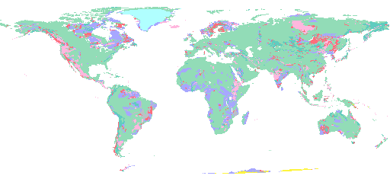
Click “continue to interactive” and answer the following questions. Make sure the month is set to January, Earth’s tilt is at 23.5 degrees, and SHOW tropics and equator.

- Compare and contrast the average temperatures for Anchorage, Chicago, Quito, and Melbourne in January.

- Rank the four cities according to their daylight hours in January. (rank least hours to most hours)

- Explain why the ranking in question 10 occurs.

- Change the month to March. Which hemisphere of the Earth is tilted toward the sun?
- Which month would you want to visit Anchorage in order to have maximum daylight hours?

- Explain why Anchorage has maximum daylight during that particular month, based on the position of the Earth and Sun.

- Click through all 12 months and describe the temperature variation for the year in Quito, Equador.
- Explain the temperature variation you observed.

- What type of clothing would you pack if you were visiting the city below during July:
- Melbourne, AUS
- Chicago, IL

- The United States experiences the summer season during July:
- Explain why?

- Explain the difference in average temperature between Anchorage and Chicago.

Look at “Distance Between Earth and Sun” at the far right as you click on different months.
- Which month(s) is the Earth farthest from sun? _______________________________
- Which month(s) is the Earth closest to the sun? _______________________________
- Which month do all four cities have approximately the same number of daylight hours and temperatures?
______________________________________
- Identify the season’s for all four cities during this month:

Anchorage______________ Chicago____________ Quito________________ Melbourne_________

- Which of the four cities would have a climate most similar to Denver, CO? Explain your answer.

- Put the Earth’s tilt at 0 degrees.
- Explain what happens to the average daylight hours for all four cities and why.

- Explain what happens to the average temperature for all four cities and why.

- Based on what you have learned in this activity, explain why there are seasons on Earth.

Use the following website answer the 2 questions below.
Website:
http://www.classzone.com/books/earth_science/terc/content/investigations/es2101/es2101page01.cfm?chapter_no=investigation

- What is climate?

- There are many factors that affect an area’s climate. Identify at least 7 factors in the table below with the name and a description for each of these factors.
Name of Climate-affecting Factor | Description

