Name _________________________________________ Date ____________ Period _______
Carrying Capacity and the Reindeer of St. Matthew Island
(Adapted from Looking at the Environment 2003 from Northwestern University)

Overview
As we begin to look more closely at the biotic and abiotic factors in an ecosystem and the organisms that depend on these factors for life, we notice how interdependent life truly is. Resources like food and energy are limited, and many organisms are in competition for these resources. In this activity, you will examine factors that affect the size of a population. These factors are called "limiting factors” because they limit the size of the population. A limiting factor can be either a biotic factor or an abiotic factor. All of the limiting factors combined determine the maximum number of any species that an ecosystem can support for a long period of time. This number is called the “carrying capapcity”.

Procedure
1. Read the following article summarizing the reindeer introduction on St. Matthew Island.
2. Construct a graph based on the data showing the population of the reindeer population as time goes by.
3. Answer the analysis questions.

Reindeer of St. Matthew Island
Although it is difficult to imagine, the world in which we live is a closed system, possessing a limited amount of the resources which support the organisms that exist in the system. Our biosphere is made up of many complex and diverse ecosystems around the world, all interacting and impacting each other. Because of the interactions between these systems, all of the organisms in each of these ecosystems have an effect on the balance of populations and resources.

Perhaps the size of our planet makes it difficult to believe that what one population does anywhere on
the planet will impact the health and success of other populations elsewhere on the planet. Although examples of the impact of imbalances within global ecosystems exist, the relative isolation of island ecosystems makes islands a good place to study the impact a single organism can have on the balance of an ecosystem.
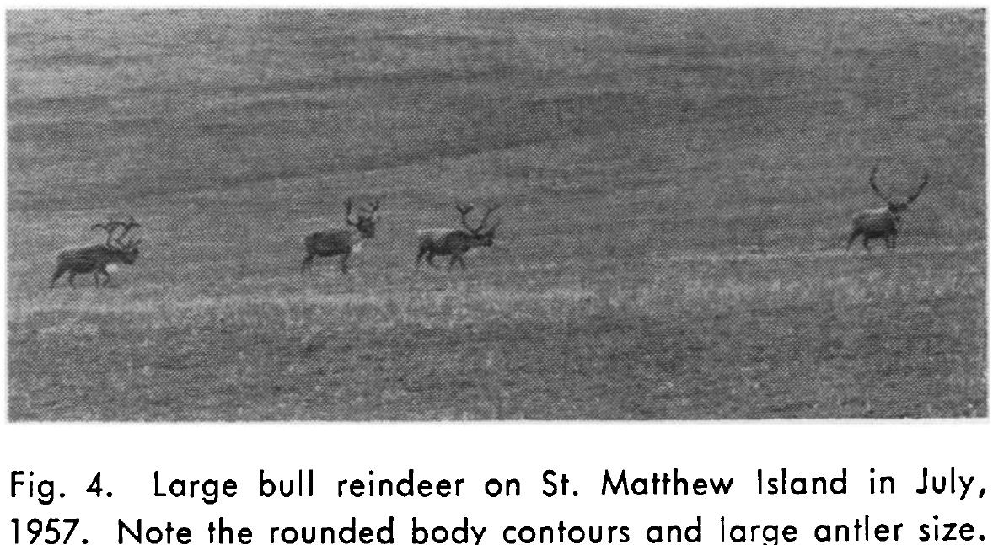
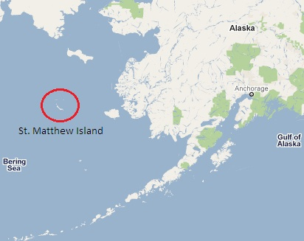

Take, for example, the case of the reindeer population on St. Matthew Island in Alaska. St. Matthew Island is located in the Bering Sea Wildlife refuge off of the southwest coast of Alaska. The island is 128 square miles of poorly developed land vegetation, low growing tundra grasses, and a few dwarf-variety willows. Elevations reach 1500 feet. Annual rainfall, including snowfall, is 10-17 inches. Wind speeds are usually high and fog can be present year round. The island supports populations of singing voles, arctic fox and
many species of sea birds. A remote coast guard station on the island was abandoned in 1944 and has remained uninhabited ever since.

In 1944, twenty-four reindeer were introduced onto the island. By “introduced”, we mean that the reindeer were not native to the island’s ecosystem. The island’s environment supplied a rich food source for the reindeer and was free of predators.

At the time of introduction, scientists estimated that the island’s carrying capacity was between 1,600 and 2,300 reindeer. Responding to the high quality and quantity of forage (grasses and shrubs) on the island, the population of reindeer reached 1,350 by 1957. The average body weight of the reindeer on St. Matthew Island at that time exceeded those in domestic herds by 24%. With no natural controls or predators the population soared to 6,000 by 1963. Over the next three years the population exhausted the island’s food resources and crashed, leaving only 42 reindeer inhabiting St. Matthew Island.

Reindeer on St. Matthew Island from 1940 to 1975
Time (years) | Reindeer population
1940 | 0
1941 | 0
1942 | 0
1943 | 0
1944 | 0
1945 | 0
1946 | 25
1947 | 50
1948 | 75
1949 | 100
1950 | 150
1951 | 250
1952 | 300
1953 | 450
1954 | 550
1955 | 800
1956 | 1,000
1957 | 1,350
1958 | 1,500
1959 | 2,000
1960 | 3,000
1961 | 4,000
1962 | 5,800
1963 | 6,000
1964 | 5,200
1965 | 2,500
1966 | 43
1967 | 0
1968 | 0
1969 | 0
1970 | 0
1971 | 0
1972 | 0
1973 | 0
1974 | 0
1975 | 0
Analysis Questions

- Describe the change in reindeer population over time based on the data you graphed.

- Explain why the line you graphed to show the change in the reindeer population is not linear.

- Identify three reasons the reindeer population on St. Matthew Island exploded.

- Identify three reasons the reindeer population crashed.

- How did the reindeer population affect the environment on the island?

- Based on what you read in the text and an analysis of your graph, explain how the change in the reindeer population is an example of “carrying capacity”.

- Did the reindeer population exceed the carrying capacity of the island? Use numbers to support your
answer.

- Explain how the effect of changes in “limiting factors” were evident in the St. Matthew Island reindeer population.

