Name ____________________________________________ Per ________ Date _______________
Unit 2 TEST Review: Bonding, Naming, Lewis Structures, Shapes and IMFs
Answer all of the following questions and use Learning Goals, Labs, and Worksheets to prepare for the U-4 test.
- Complete the following table.
Element | Valence Electrons | Number of e- lost or gained | Most likely charge on ion | Metal or Nonmetal | Type of compound formed with nitrogen (ionic/covalent)
O
Sr
Al

- Write what you would expect to observe for each substance in each of the following situations. Explain each answer.

a. paradichlorobenzene (C₆H₄Cl₂) and potassium carbonate (K₂CO₃) are both heated on a hot plate

b. zinc metal and sodium chloride are both stirred into separate beakers of water

c. glucose (C₆H₁₂O₆) and calcium chloride are both dissolved in water and the conductivity is tested

- Write the name or the formula of the following compounds. (first, decide if it’s ionic or covalent)
Compound Name | Compound Formula
Barium hydroxide
 | P₂S₅
 | AlPO₄
Carbon tetrafluoride
Iron (III) oxide
 | Cu(NO₃)₂
 | ZnBr₂
Nitrogen monoxide

- Identify the type of bonds in each substance below and describe how the bonds are formed (electron behavior).

a. SO₂ b. Ni c. KF
- Draw Lewis Structures for the following ionic and covalent compounds. For ionic compounds, the shape is a lattice.
Compound | Lewis Structure | Number of bonds and unshared pairs on central atom | Shape and bond angle | Molecular Polarity  (polar, nonpolar or ionic) | Intermolecular forces
KBr |  |  |  | NA | NA
CF₃OH
Br₂

MgF₂ |  |  |  | NA | NA
PBr₃

NO₂⁻¹

CHOOH

- State what VSEPR stands for and how the VSEPR theory is used to predict the shapes of molecules.
Compare the shapes of H₂S and SiS₂ to support your explanation. (draw Lewis structures)

- Explain the difference between a polar and a nonpolar molecule. Use 2 examples from the table in question (2) to support your explanation. Show where the (+) and (-) poles would be on each molecule.

- Intermolecular forces and bonds.
  - Identify the most significant intermolecular force that occurs in the examples shown below and indicate where it is with a label and an arrow.
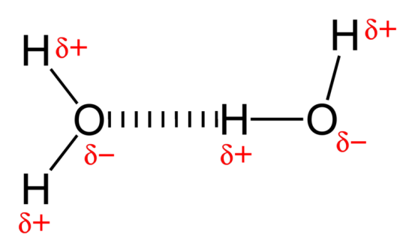
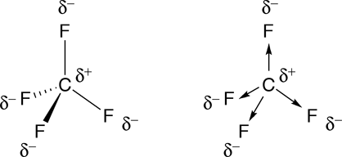

b. Identify a covalent bond in each molecule and indicate where it is with a label and an arrow.

c. Explain what happens to the molecules above during melting or evaporation.

d. Explain why the 2 molecules above, H₂O and HCl, would have different melting points or rates of evaporation.

e. Identify any molecules above that would dissolve in water and any that would not. Explain why.

- Use the following substances to answer a-d:
H₂S, CaI₂, Cl₂, NH₂F
  - Write Lewis structures, identify shapes, and state polarity for each substance above.

  - Identify the type of IMF in each substance and rank them in order from weakest IMFs to strongest IMFs.

  - Explain your ranking by comparing IMF’s.

  - Which substance would evaporate the fastest? Explain why.
  - Identify the substance that must be a solid at room temperature. Explain your choice.

  - Draw a diagram showing how an NH₂F molecule and an adjacent water molecule would align and identify (label) the intermolecular forces.

