Name __________________________________________ Date ___________Period _____
Review of Energy Flow in Ecosystems

- For each picture or pair of organisms, identify the type of symbiotic relationship as: mutualism, parasitism, or commensalism. Explain your identification.
- Epiphytes are small plants that grow on the bark of trees in rainforest.
Type of relationship:

Explain:
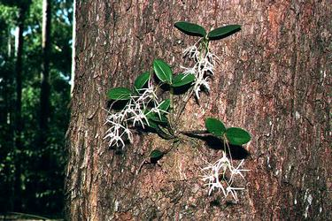

- The algae that lives in the fur of the 3-toed sloth provides camouflage for the sloth.
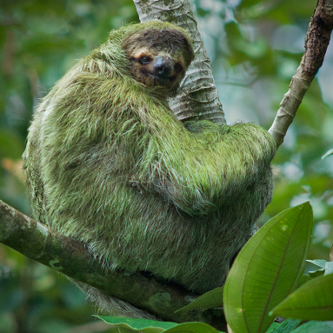
Type of relationship:

Explain:
- Give your own example below.

Type of relationship: Parasitism

Explain:

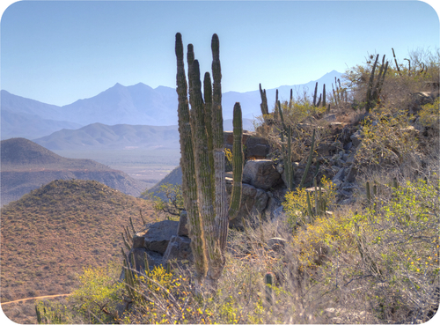
- Based on the Desert ecosystem to the right;
- Identify 2 biotic factors and 2 abiotic factors that limit the cactus
population.

b. Make a food chain, with at least 4 organisms for the desert ecosystem. Show arrows.
__________________ ___________________ ___________________ __________________
c. Add the sun and a decomposer to show how how each interacts with the food chain.
d. Organize the organisms from your food chain into the pyramid
at the right.
e. Identify each trophic level (by number)
and label as producers and consumers (prim, sec, etc.).
f. The producers have 250,000 kJ of energy.
Determine the energy for each other level in the energy
pyramid and write the value on the pyramid.
g. Explain why an energy pyramid is shaped this way.

h. How much energy is passed on to a higher trophic level? AND, what happens to the energy that is not passed on to the next trophic level?

- Give an example of 2 decomposers. Describe their role in the biosphere?

- Identify a similarity and a difference between autotrophs and heterotrophs. Give an example of each.

- Write a balanced equation (using words or formulas). Label the reactants and the products.
a. Photosynthesis:

b. Cellular respiration:
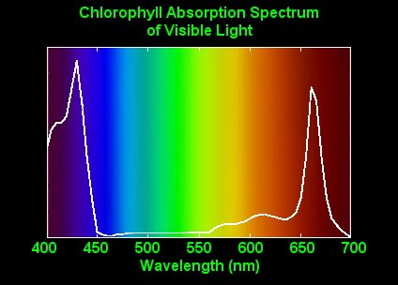
V I B G Y O R
- Name the part of the cell where photosynthesis takes place and
identify the pigment that absorbs light.

- Identify the colors and corresponding wavelengths that
chlorophyll absorbs the most? Least?

- Identify 2 biotic variables and 2 abiotic variables in your ecosystem study

biotic ___________________________________________________

abiotic ___________________________________________________
9. Describe how a change in a biotic variable may have affected one of the abiotic variables.

Change in Biomass of Algae, Daphnia and Hydra over one year
Study the graph at the right showing the biomass of algae, daphnia, and hydra in a small fresh water pond. A change in biomass indicates a change in population.

a. Sketch an biomass pyramid with biomass numbers for the month of April. The size of the trophic level should correspond to the biomass.

b. Do the same for August.
10.
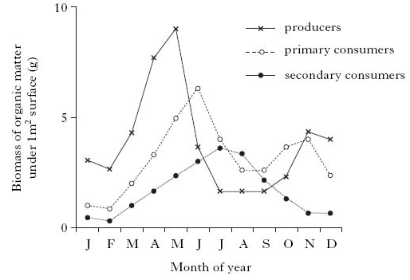

Algae

Daphnia

Hydra

c. Which pyramid seems to represent the most stable populations? The least stable? Explain

d. How does this graph show a predator / prey relationship?

e. Estimate the carrying capacity for the daphnia population and extend the daphnia line to show the carrying capacity being achieved.

f. Suggest a change in a limiting factor that may have caused the hydra population to decrease from August to December.

