Name ______________________________________________ Date ___________ Period _____
Unit 1 Review – States of Matter and Gas Laws

- State at least 3 assumptions regarding properties of gas particles according to the kinetic theory of gases (matter).

- Complete the following table.
 | Solid | Liquid | Gas
Illustration
* Draw molecules of a solid, liquid and gas
Properties
* List at least 2 properties of each
Phase Changes
*Identify 2 phase changes and describe the change in particle behavior

Use the phase change diagram to answer 3-5.
3. Identify the phase (solid, liquid, gas) that the following letters represent on the phase change diagram:
A _________________________________
B _________________________________
C &D ______________________________

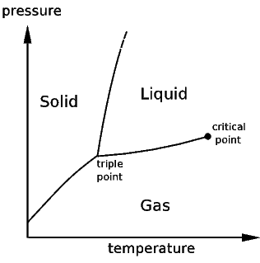
D
A
B
C
4. What phase exists at high pressure and low temperature? Explain why.

5. Which phase change occurs when the substance: (draw arrows on the graph for each change below)
a. is heated from point A to B under constant pressure ___________________
b. undergoes an increase in pressure from point C to B ___________________

c. undergoes a decrease in pressure from point A to D ________________
- Identify the following relationships as inverse or direct. Explain the relationship using the kinetic theory of gases. Sketch a graph for each.

  - Pressure and volume b. Pressure and temperature c. Volume and temperature

Vapor pressures at Different Temperatures Use the graph at the left to answer questions 7-10.
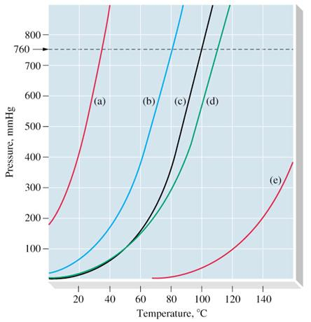
7. What is the vapor pressure of substance (d) at 80ºC? _______
8. At what temperature will substance (a) boil if the atmospheric pressure is 400 mmHg? _________

9. What is the boiling point at standard pressure of substance (b)? _________
10. Identify the line on the graph that most likely represents water. ______
Explain your answer.

- a. Explain the following demonstrations performed in class. Include the gas law that explains the demonstration.
- Egg in the flask
- Boiling water in cooled flask
- Crushed can

- a) Convert 97.0 kPa to atm (b) Convert 97.0 kPa to mm Hg.

C) Convert 87.3K to ºC (d) Convert -200º C to K

- A. The gas left in a used aerosol can is at a pressure of 115 kPa at 40.0 ºC. If this can is thrown into a fire, what is the pressure of the gas when its temperature reaches 755 ºC?

B. The aerosol can will explode if the pressure exceeds 350.0 kPa. Does the can explode? __________

- After driving to the mountains at constant temp, you notice that a 2.7 L chip bag has expanded to 3.4L. If the trip begins at an atmospheric pressure of 0.865 atm what is the pressure in the mountains?

- The volume of a helium-filled balloon is 30.0 L at a temperature of 313 K and 153 kPa pressure. What volume will the balloon have at standard temperature and pressure (STP)?

- A 0.105 mole sample of nitrogen gas is in an expandable container. Additional nitrogen is added so that the container expands from the initial 2.2 L to 7.0 L. How many moles of nitrogen are now in the container?
Assume that temperature and pressure are constant.

- Calculate the volume of 0.25 moles of N₂O gas at 0ºC and 0.92 atm of pressure.
R = 0.0821 atm L
mol K

R = 8.31 kPa L
mol K

- Determine the grams of chlorine (Cl₂) gas in a 995 mL container at 8.87 kPa and 23°C.

- The following reaction takes place at STP: 2 H₂O₂(l) 2 H₂O(l) + O₂(g)
If 30.0 g of hydrogen peroxide (H₂O₂) decompose, what volume of oxygen (O₂) is produced?
Hint: Use the standard molar volume of a gas.

- Use the data provided to answer questions a-f. Combustion of Ethene: Pressure, Temp, Volume
Atmospheric Pressure | 96.3 kPa
Temperature | 25ºC
Volume of gas (CO₂) produced | 40.0 mL
In an experiment, ethene gas (C₂H₄) is burned in the presence of oxygen to produce carbon dioxide gas and water. The balanced equation for this reaction is: C₂H₄(g) + 3O₂(g) 2CO₂(g) + 2H₂O(l)

  - The CO₂ is collected over water. Therefore, CO₂(g) and H₂O(g) are present in the collection container and the pressure of the mixture is equalized to atmospheric pressure. If the vapor pressure of the H₂O_{(g)} is 3.2 kPa, what is the partial pressure of carbon dioxide?

  - Calculate the moles of CO₂ produced using the data provided.

  - Assuming all of the CO₂ produced was actually collected, determine the moles of C₂H₄ burned.

  - What volume of oxygen gas (O₂) at STP, would be required to produce 18.5 g of CO₂? Assume excess C₂H₄.

  - One group of students forgot to subtract the pressure of water vapor from the total pressure before calculating moles of CO₂. How would this error affect the moles of CO₂ calculated? Explain on a molecular level.

  - Another group of students did not allow the reaction to go to completion. How would this error affect the final volume of gas collected? AND, how would this error affect moles of CO₂ calculated? Explain your answer.

21. a. Use the pressure, volume data below to make a graph on the computer. Plot pressure on the Y axis and volume on the x axis. Make a scatter plot and apply a smooth, best-fit line. Make sure your graph is EDR excellent and attach a copy.
b. Determine the missing values in the data table using your graph or calculations.
