Name _______________________________________________ Date _________ Period _____
Determining Geologic Age of Rocks and Index Fossils: Part 1, Correlating Rock Layers
Background Information:
Sediments are small pieces of rock that are moved and deposited by water, wind, glaciers, and gravity. These sediments form due to weathering and eventually become sedimentary rocks. Usually these pieces accumulate in horizontal layers where a river, a glacier, the wind, or ocean waves deposit them. Then, over millions of years, the sediments are pressed tightly together due to pressure from overlying rock layers or they are cemented together by minerals that have been dissolved in water. Geologists can often see the original grains in the sedimentary rock, even when they are extremely small, which helps determine the type of sedimentary rock. The type of sedimentary rock, as well as special features, tell the geologist a great deal about the environment where the rock formed. For example, a sandstone with ripple marks could very likely have formed by wind or wave action.
Often, if the environment changes, the type of sedimentary rock also changes. It is not unusual to see a layer of limestone, which forms at the bottom of an ocean, directly below a layer of sandstone, which is the result of waves depositing sand on a beach. The geologist observing these rock layers realizes that millions of years ago an ocean environment slowly changed to a beach environment when the ocean receded (moved back).

In a sequence of sedimentary rock layers, each layer is older than the layer above it and younger than the layer below it. As time goes on younger beds are laid down on top of the older beds. This order of layering is called the Law of Superposition. A section of rock that is exposed, so that the various layers can be seen, is called an outcrop.
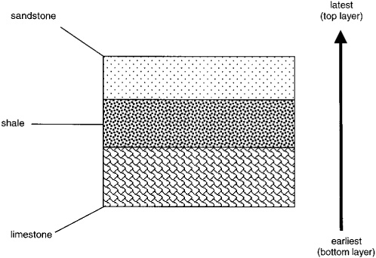
Youngest (top layer)

Oldest (bottom layer)
A geologist examining an outcrop pays close attention to the layers of rock that are present and tries to determine if layers might be missing from the sequence, or rock record. This occurs when rock layers at the top are eroded or weathered away before new beds are laid down. In this case, there is a gap between older and younger rock layers in the sequence.
D | layers C and D  have been eroded away | F
C |  | E
B |  | B
A |  | A
Erosional Surface

When geologists study layers of rocks looking for clues to their age and the environment in which they formed, they look at the type of rock, erosional surfaces, and other features such as fossils. Fossils, which are evidence of past life, provide incredibly useful information about the age of the rock and its environment. Fossils are usually found only in sedimentary rocks because they can be preserved even as the rocks are compressed or cemented. Geologists today use index fossils and groups of fossils to determine the relative age of rock layers. An index fossil is the fossil of an organism that once lived in many locations and was very abundant. However, index fossils are fossils of organisms that lived only for a limited time. The presence of an index fossil in rock layers at different locations means that the corresponding layers formed at nearly the same time or are very close to the same age.
In this lab, you will examine 6 drawings of rock outcrops that contain sedimentary layers with index fossils. The Law of Superposition and the presence of index fossils (indicated by numbers on each layer) will help you determine the relative ages of the different layers and order them from oldest to youngest. A straight line in the outcrop indicates continuous deposition and a wavy line indicates that layers of rock are missing due to erosion.
Borrero, F., et al. (2013) Earth Science, Geology, the Environment, and the Universe. Bothell, WA: McGraw Hill
Pre-Lab Questions:
- Describe how an environment can influence the type of sedimentary rock formed.

- Give an example of how a scientist might know that an ancient environment had changed based on the layers of sedimentary rock.

- Write a definition for the Law of Superposition in your own words.

- Write a definition for index fossil in your own words.

- How do the Law of Superposition and observations of index fossils help geologists determine when a rock layer was formed?

Procedure:
- Use the space below to put the rock layers from the six outcrops in order from oldest to youngest. Write youngest at the top of the space and oldest at the bottom.
- The numbers in the rocks can be used to identify the layers but they also represent index fossils found in that layer. The numbers have nothing to do with the order of the rock layers.
- Start with 2 or 3 outcrops and then add in layers from the other outcrops. Leave spaces to insert layers.
- Some layers may be the same age. Some layers may overlap several layers.

Analysis / Conclusion Questions:

- Which of the rock layers do you think is the oldest? Explain why.

- Which of the rock layers do you think is the youngest? Explain why.

- Which rock layer(s) was/were hard to place in the sequence? Explain why you put it/them where you did.

- Would the type of fossil represented by #8 or #17 be a true “index fossil”? Explain your thinking.

- Explain why index fossils #7 and # 12 can be found below either #1 or #18 in outcrops B and C.
And then, explain why you don’t see #7 and #12 below #1 and #18 in outcrop E.

