NAME __________________________________________________ PERIOD _____ Date _________
PROPERTIES OF SOLUTIONS: Do you have one?

- Would you expect sodium nitrate crystals (NaNO₃) to dissolve in water? Explain why.
Identify 3 ways to dissolve a large sodium nitrate crystals as quickly as possible?

- Explain what is happening, on a particle level, when a solute dissolves in a solvent. Draw a diagram showing solute particles and solvent particles.

- Electrolytes are substances that break up into ions when in water. These ions are capable of conducting an electrical current. Compounds that do not form ions in water are nonelectrolytes.
Put an X in the appropriate column below to classify if you would expect the substance to behave as an electrolyte or a nonelectrolyte.
Compound | Electrolyte | Nonelectrolyte | Number of Particles Formed
MgCl₂
Br₂
C₃H₅(OH)₃
HCl
NaOH

4. Go to the PhET simulation website and choose Play with Simulations, Chemistry, Sugar and Salt Solutions. Click on the Macro tab.
a. Record observations of salt in water:

b. Record observations of sugar in water:

Click on the Micro tab and do the same thing. Focus on differences between salt and sugar in your observations.

c. Record and sketch observations of salt in water:

d. Record and sketch observations of sugar in water:

Click on the Water tab and repeat the process for dissolving salt in water and then sugar in water.
Select “Water Partial Charges” and focus on the water molecules and how they are oriented to the solute.
e. Record and sketch observations of salt in water:

f. Record and sketch observations of sugar in water:

g. Explain any similarities and differences in the way that salt and sugar dissolve.
Include polarity in your explanation.

h. Describe and sketch the similarities and differences when NaCl dissolves and when MgCl₂ dissolves.

5. Describe how you would know if a solution of copper (II) sulfate is saturated or unsaturated?

Use the solubility curve below to answer questions 9 – 14.
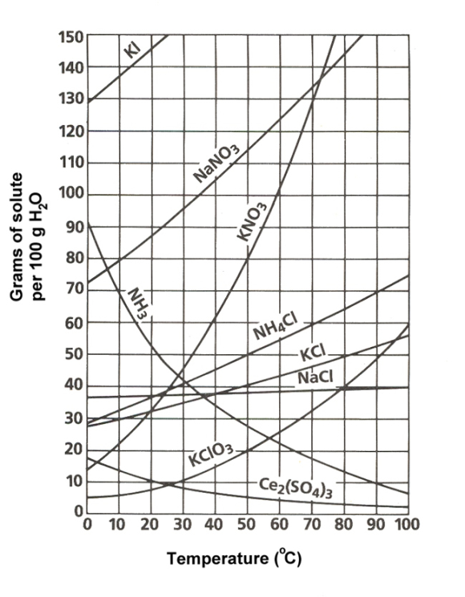
9. In general what happens to the solubility of an ionic compound when temperature increases? How is a gas different?

10. If you mixed 60.0 g of KCl in 100 g of water at 70.0˚C, would the solution be saturated or unsaturated?

11. How many grams of KNO₃ would you need to saturate 100 mL of water at 70˚C?

12. What is the lowest temperature you could use to fully dissolve 65 grams of NH₄Cl in 100 g of H₂O?
13. How many grams of KClO₃ would dissolve in 50 g of H₂O at 90˚C? In 200 g of H₂O? In 350 g of H₂O?

- What mass of ammonia gas (NH₃) would be dissolved in 200 g of H₂O at 60˚C? What would happen to the mass of ammonia gas dissolved if the solution is warmed to 80˚C?
- Consider a 20 oz bottle of Coke:
- What does the soda look like before you open the lid?
- What does it sound like when you open the lid? Why?

- What would it sound like if you heated it up and then opened the lid? Why?
- Are the concentrations of CO₂ and sugar the same or different after opening the lid? Explain.

