Statistical Analysis Practice Name: __________________
T-test: t-value & p-value Date: _________ Per: ____
IB Bio Year 2
Ms. Chen

Table 1: Data from a bean plant experiment

Height of 10 bean plants grown in sunlight, in centimeters ±1 cm | Height of 10 bean plants grown in shade, in centimeters ±1 cm
125 | 131
121 | 60
154 | 160
99 | 212
124 | 117
143 | 65
157 | 155
129 | 160
140 | 145
118 | 95

Calculate the following
Mean:

Standard Deviation:

What does the Standard Deviation tell you about the variability of the data?

What is causing this wide variation in data? Is it possible that the plants in the shade are also growing in several different types of soil? Is it from chance alone or from a factor besides chance?

- Calculate the t-value from the mean and standard deviations of beans grown in the sunlight and shade with the following equation:
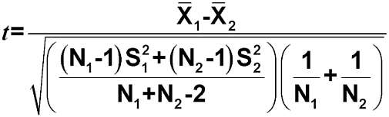

X₁ = Mean of first set of values
X₂ = Mean of second set of values
S₁ = Standard deviation of first set of values
S₂ = Standard deviation of second set of values
n₁ = Total number of values in first set
n₂ = Total number of values in second set.

- Use the table of critical t-values (Table 2) to find out what this t-value means. To do this, look in the left-hand column of Table 2, headed ‘Degrees of freedom’, then look across to the given t-values. For a two-sample t-test like the one we are doing, the degrees of freedom (d.f.) are the sum of the samples sizes of the two groups minus two.

Find the (d.f.) that corresponds with the bean plant’s sample size. Find the p-value that corresponds with the closest t-value to your calculated t-value. (Note: the t-value table does not go past 50%, if you use excel it will give you an exact p-value)

Practice Problem:
Two groups of barnacles living on a rocky shore were compared. The width of their shells was measured to see whether there was a significant size difference depending on how close they lived to the water. One group lived between 0 and 10 m above the water level. A second group lived between 10 and 20 m above the water level.

The width of the shells was measured in millimeters (mm). 15 shells were measured from each group. The mean size of the group living closer to the water indicated that barnacles living closer to the water had larder shells.

If the t-value = 2.25, is that a significant difference? Is the null hypothesis supported or rejected?

(Null Hypothesis) H₀:

(Alternative Hypothesis) H₁:

