Name __________________________________________ Date _______ Period ___
Unit 3 Review: Properties of Light, and Electron Arrangement

1. Name the following.
a. An atom that has lost electrons will form a ________________ ion called a(n) _____________

b. An atom that has gained electrons will form a _______________ion called a(n) ______________

2. Draw a sketch of an atom for each scientist below and describe one revision that improved the previous model below each sketch.

Niels Bohr | Heisenberg and Schrodinger

3. A photon is emitted from an atom and has a frequency of 4.62 x10¹⁴ s⁻¹ .
c = 3.0 x 10¹⁷ nm/s
= 3.0 x 10¹⁰ cm/s
= 3.0 x 10⁸ m/s

h = 6.63 x 10⁻³⁴ J∙s
- Determine the wavelength of the photon?

- Determine the energy of the photon?

- Identify the color of the photon and explain your identification? (use your book, ws, or a reliable website)

4. A different photon has a wavelength of 630 nm.
- Determine the frequency and energy of this photon.

- Sketch and label 2 waves, one representing the photon in (#3) and one the photon in (#4). Include a comparison of wavelength, frequency, and energy.

5. Summarize the following rules or principles and label an orbital diagram to demonstrate each one.
- Aufbau Principle

- Hund’s Rule

- Pauli Exclusion Principle

- Write an orbital diagram (use boxes or not) for a neutral oxygen atom and show how the rules above apply.

6. For each sublevel below, tell how many orbitals there are and the maximum electron capacity.

s p d f
7. Write complete electron configurations for each of the following.

Ca ___________________________________________________

As ____________________________________________________

F ____________________________________________________

S²⁻ ____________________________________________________

Al⁺³ ____________________________________________________

8. Using the abbreviated (short cut), write the electron configurations for the elements/ions below.

Ge __________________________________________________

Au __________________________________________________

As⁻³ __________________________________________________

9. Write an orbital diagram for each of the following:

P

Na

Ne

Ti

10. Given the electron configuration of the last sublevel filled, identify the element.
(Assume ground state atoms)

3p⁶ _____________________

4d³ _____________________

5s² _____________________

5f³ ____________________

11. Use your understanding of electron arrangement to identify the following NEUTRAL elements.

- The e⁻ configuration is: 1s²2s²2p⁶3s²3p⁴ ___________

- Contains one electron in 3d when in the ground state ___________

- Contains only seven electrons in the 3rd energy level in the ground state ___________

- The e⁻ configuration is: 1s²2s²2p³3s² when the atom is in the excited state ___________

- Contains three unpaired electrons in the 2p sublevel in the ground state ___________

12. Use the graph below to answer questions a-d.
- Describe the trend between energy and wavelength as shown on the graph.

- Give an approximate wavelength for a photon with an energy of
3.5x10⁻¹⁹J.

- The points A, B, and C represent bright lines emitted by mercury atoms. One line is green, one is blue, one is violet and one is orange. Label the points with their respective colors. Explain your labeling.
Change in Photon Energy as Wavelength Increases
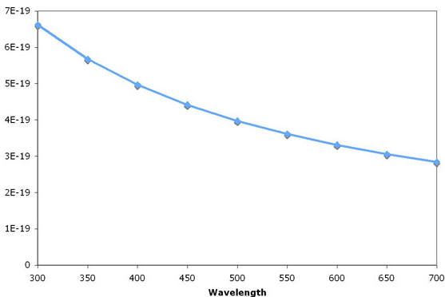
A B C D
Energy (J)
Wavelength (nm)

- Which point, A, B, C, or D, would represent the highest frequency photon? Explain.

- Sketch a graph of Energy vs Frequence. Is this a direct or an inverse relationship?

